**Reformulation of Geometric Optics within the Framework of Abelian U(1) Gauge Theory: A Novel Approach to Understanding Light Propagation**

**Adrianus Inu Natalisanto1* and Sri Purwaningsih2**

*1 Prodi Fisika, Lab Fisika Teori dan Material, Fakultas Matematika dan Ilmu Pengetahuan Alam, Universitas Mulawarman, Jl. Barong Tongkok, Gn. Kelua, Samarinda Ulu 75242, Samarinda, Kalimantan Timur, Indonesia*

*2 Prodi Fisika, Fakultas Sains dan Teknologi, Universitas Jambi, Jl. Lintas Jambi-Ma.Bulian Km 15 Mendalo Darat 36361, Jambi, Indonesia.*

*\*Corresponding Authors E-mail:* [*adrianus@fmipa.unmul.ac.id*](mailto:adrianus@fmipa.unmul.ac.id)

|  |  |  |  |
| --- | --- | --- | --- |
| **Article Info** |  | **Abstract** | |
| ***Article info:*** *Received: xx-xx-20xx*  *Revised: xx-xx-20xx*  *Accepted: xx-xx-20xx* ***Keywords:*** *Geometrical optics, Abelian U(1) gauge theory, Light propagation.*  ***How To Cite:***  *A. I. Natalisanto and S. Purwaningsih, “Reformulation of Geometric Optics within the Framework of Abelian U(1) Gauge Theory: A Novel Approach to Understanding Light Propagation”, Indonesian Physical Review, vol. 5, no. 2, p 100-108, 2025.*  ***DOI:***  *https://doi.org/10.29303/ipr.v8i2.464.* |  | *This study introduces a reformulation of geometrical optics through the framework of Abelian U(1) gauge theory. By leveraging this novel approach, phase equations are derived, serving as the cornerstone for determining the trajectories of light rays. The proposed formulation is validated through simulations of light propagation in diverse scenarios, including homogeneous refractive index media, vacuum, anisotropic materials, and optical metamaterials. These results underscore the versatility and predictive power of this gauge-theoretic approach, opening new avenues for exploring and modeling complex optical phenomena.* | |
|  |
|  |
|  |  | *Copyright (c) 2024 by Author(s), This work is licensed under a Creative Commons Attribution-ShareAlike 4.0 International License.* |

**Introduction**

Geometric optics is one of the classical approaches in physics to describe the propagation of light, especially in the limit of very small wavelengths (𝜆→0). This approach uses the concept of light rays propagating through a medium with a certain refractive index. It is often used to describe the phenomena of refraction, reflection, and optical paths in various complex media [1–3]. In the electromagnetic framework, geometric optics can be derived from Maxwell's equations through the eikonal equation approach, which describes the path of light as a classical limit solution of electromagnetic waves [4–7]. This approach has also been extended to include anisotropic media and refractive index gradients using the gauge field [8–10].

Recent research has attempted to reformulate geometric optics within the framework of Abelian U(1) gauge theory [11]. Nevertheless, this reformulation, which holds potential for optical engineering, contains conceptual inaccuracies that prevent it from making valid physical predictions, such as the propagation of light in straight lines in a medium with a homogeneous refractive index or in a vacuum, as well as light refraction in optical metamaterials (with a negative refractive index) and anisotropic media.

The article also claims that the optical phase, refractive index, and propagation of light beams can be understood through gauge potentials, field strength tensors, and topological structures. This claim is mathematically intriguing as it utilizes the formalism of gauge theory, which is often used to explain particle physics and quantum field phenomena [12–18]. Previously, several studies have indeed demonstrated the application of gauge theory to light propagation in complex media, such as anisotropic media and metamaterials [19–22]. Unfortunately, the claim has not been explained in detail regarding which aspects of geometric optics are connected with gauge theory.

In the following analysis, the inaccuracies in previous research, particularly phase shifts in light, will be addressed. A corrected formulation of geometric optics within the framework of gauge theory will also be presented to ensure its physical accuracy. Simulations of light passing through homogeneous refractive index media, a vacuum, anisotropic materials, and optical metamaterials are included to demonstrate potential outcomes that could be observed in future experiments.

Comprehending phase shifts in light is essential for applications in interferometry, optical metrology, and fiber-optic communication [23–25]. Phase analysis plays a key role in material characterization, optical system design, and enhancing signal transmission across various scientific and technological fields.

**Phase Formula**

Geometrical optics in the framework of Abelian U(1) gauge field theory is proposed [11]. In ref.[11], it used the eikonal equation as a gauge theory in a (3+1)-dimensional vacuum space-time using a weak-field approximation. Key equations include the gauge potential

$A_{μ}=a_{μ}\left(r,t\right)e^{iq\left(r,t\right)}$ (1)

and the field strength tensor

$F_{μν}=∂_{μ}A_{v}-∂_{μ}A_{v}$ (2)

which describes the optical field in terms of the refractive index *n(r)* and other variables. Numerical simulations reveal that the refractive index can be approximated as *n(r)=*1.0001 in vacuum space-time and that the weak magnetic field magnitude ∣**B**∣=0.10452 T supports the weak-field approximation.

The vacuum space-time is interpreted as a weak-field limit, where electromagnetic fields are of very low intensity. The study introduces the phase *q(***r***,t)*, related to the refractive index, expressed as:

$q\left(r,t\right)=X\left\{\int_{r_{1}}^{r_{2}}{n\left(r\right)}d^{3}r-ct\right\}$, (3)

where X is a constant and the integral is take along the space. The refractive index is modeled as

$n\left(r\right)=n_{0}\left(1-\frac{ar^{2}}{2}\right)$, (4)

showing that it decreases with increasing distance from the source. In ref.[11], it used the amplitude *ρ*(**r***,t*) and phase *q*(**r**,t) in the scalar field

$ϕ\left(r,t\right)=ρ\left(r,t\right)e^{iq\left(r,t\right)}$, (5)

highlighting the scalar field’s topological and isotropic properties in a vacuum.

Numerical results show the refractive index decreases radially, confirming vacuum characteristics. The study also finds the weak magnetic field magnitude ∣*B*∣=0.10452 T, computed using.

$B=∇×A$. (6)

These findings might reveal an innovative perspective connecting geometrical optics with gauge field theory, opening new avenues for exploring topological structures and weak-field conditions.

**Correction of the Phase Formula**

The revised phase formulation of geometric optics within the framework of gauge theory provides a more accurate description of light propagation in graded-index media and under weak-field approximations. In graded-index media, this approach enables precise modeling of light bending and refraction caused by spatial variations in the refractive index, thereby improving predictions of light focusing and beam shaping. Under weak-field conditions, the formulation ensures accurate modeling of light ray trajectories, even in the presence of small perturbations, effectively capturing subtle effects often overlooked in classical geometric optics.

In this section, the phase equation (Equation (3)) will be investigated using fundamental concepts following the correction process with steps as shown in Figure 1.

|  |  |
| --- | --- |
| Formulating:  Comparing:  Correcting: | Light  in a vacuum (k)  Light in  a medium (k’)  Phase (q)  End  No  Correction of Eq. (3)  Equal to  Eq. (3)?  Yes |
|  | **Figure 1.** Flowchart of the correction process. |

The visible light wave propagates through a vacuum with a velocity of [1,2,5]

$c=\frac{ω}{k}$ (7)

where *f* is the frequency of the light, *ω* is the angular frequency, $λ$ is the wavelength of the light, and *k* is the wave number of the light, along with

$ω=2πf$ (8)

and

$k=\frac{2π}{λ}$. (9)

When the light propagates through a medium, a change in the wavelength occurs, while the frequency remains constant. The wave speed of light in the medium then becomes

$v=\frac{ω}{k^{'}}$ (10)

with

$k^{'}=\frac{2π}{λ^{'}}$. (11)

Meanwhile, the refractive index is defined as [1,2,5]

$n=\frac{c}{v}$. (12)

The combination of Equations (10) and (12), followed by rearrangement, will yield the equation

$k^{'}=\frac{ω}{c}n$. (13)

The wave speed of light in the medium also satisfies the equation [1,2,5]

$v=\frac{l}{t}$ (14)

where *l* is the distance traveled by light within the medium and *t* is the time interval for light propagation through the medium.

The optical path length or the distance effectively traveled by the light wave is defined as [1,2,5]

$Δ=ct$. (15)

The combination of Equations (12), (14), and (15) will yield the equation

$∆ =nl$. (16)

Multiplying Equation (10) by *l* and relating it to Equation (16), the resulting equation will be

$k'l=\frac{ω}{c}Δ$. (17)

The phase in Equations (1) and (5) satisfies the equation [1,2,5]

$q\left(r,t\right)=k^{'}l-ωt$. (18)

The combination of Equations (17) and (18) will yield the equation

$q\left(r,t\right)=\frac{ω}{c}\left(Δ-ct\right)$. (19)

When light travels along a path *l* defined by the position vectors ***r1​*** and ***r2*​**, the optical path length, as shown in Figure 2, will satisfy the equation

$Δ=\int_{r_{1}}^{r_{2}}{n\left(r\right)dl}$. (20)

The phase of the light wave therefore satisfies the combined Equations (19) and (20), expressed as:

$q\left(r,t\right)=\frac{ω}{c}\left(\int_{r_{1}}^{r_{2}}{n\left(r\right)dl}-ct\right)$. (21)

Based on Equation (21), it can be concluded that Equation (3) contains a mathematical form that is not physically clear, namely: $\int_{r_{1}}^{r_{2}}{n\left(r\right)}d^{3}r$. The correct form of the integral should be: $\int_{r_{1}}^{r_{2}}{n\left(r\right)}dl$, which corresponds to the concept of optical path length [1-4].

**Consequences of the Correction**

The refined phase formulation improves the prediction of phenomena such as light bending and phase shifts in various media, including homogeneous media, vacuum, anisotropic materials, and optical metamaterials. This section demonstrates that the revision provides an accurate approximation of light wave propagation through the derivation of the light ray trajectory equation (geodesic equation) and the presentation of light ray trajectories in the media via numerical simulations.

**Optical geodesic equation**

Referring to Equation (21), Equation (3) is revised to become:

$q\left(r,t\right)=X\left\{\int_{r_{1}}^{r_{2}}{n\left(r\right)}dl-ct\right\}$. (22)

In Equation (22), one may select

$q_{1}=\int_{r_{1}}^{r_{2}}{n\left(r\right)}dl$. (23)

The shortest optical path length of the light wave from **r1** to **r2** at any given time satisfies the condition in accordance with the principle of least action, or Fermat’s principle in optics [1–3]:

$δq_{1}=0$. (24)

The variation of q1 is given by [26,27]

$${δq}_{1}=δ\int_{r_{1}}^{r_{2}}{n\left(r\right)}dl$$

$=\int_{r_{1}}^{r_{2}}{n\left(r\right)}δ\left(dl\right)+\int_{r_{1}}^{r_{2}}{δn\left(r\right)}dl$. (25)

In Equation (25), there are two relations, namely:

$δ\left(dl\right)=τ.δ\left(dr\right)$ (26)

and

$δn\left(r\right)=∇n.δr$ (27)

where

$τ=\frac{dr}{dl}$. (28)

By combining Equations (24), (25), (26) and (27) with calculus of variations described in [26], it can be obtained

$δq_{1}=\int_{r_{1}}^{r_{2}}{\left\{∇n\left(r\right)-\frac{dn\left(r\right)τ}{dl}\right\}.}δrdl=0$ (29)

where ***τ*** is the vector of tangential units with respect to the direction of light wave propagation.

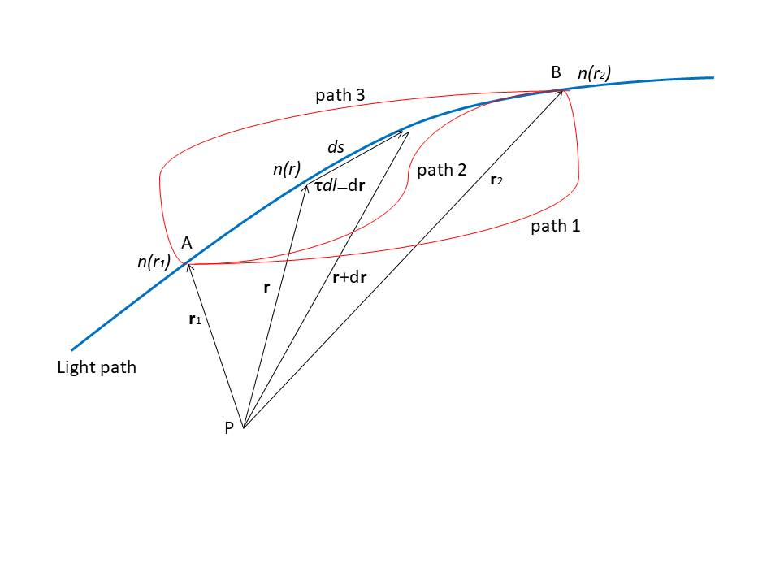

**Figure 2.** The possible trajectories of light.

From Equation (29), it can be acquired the following relationship:

$∇n\left(r\right)=\frac{dn\left(r\right)τ}{dl}$. (30)

Expanding Equation (30), it can be found the following Equation:

$∇n\left(r\right)=n\left(r\right)\frac{dτ}{dl}+τ\left(τ.∇n\left(r\right)\right)$ (31)

where

$\frac{dn\left(r\right)}{dl}=τ.∇n\left(r\right)$. (32)

Rearranging Equation (31) yields:

$\frac{dτ}{dl}=\frac{1}{n\left(r\right)}\left\{∇n\left(r\right)-τ\left(τ.∇n\left(r\right)\right)\right\}$. (33)

Meanwhile, it is known that

$τ.τ=1$ (34)

and thus, it can be determined

$τ.\frac{dτ}{dl}=0$. (35)

If the light wave propagates along a curved path with radius of curvature *R*, as illustrated in Figure 3, then the following relation holds:

$τ.\frac{R}{R}=0$ (36)

where

$R=Rη$ (37)

and $η$ is the vector of normal units (perpendicular to the direction) of light wave propagation. By combining Equations (36) and (37), it can be found

$τ.\frac{η}{R}=0$. (38)

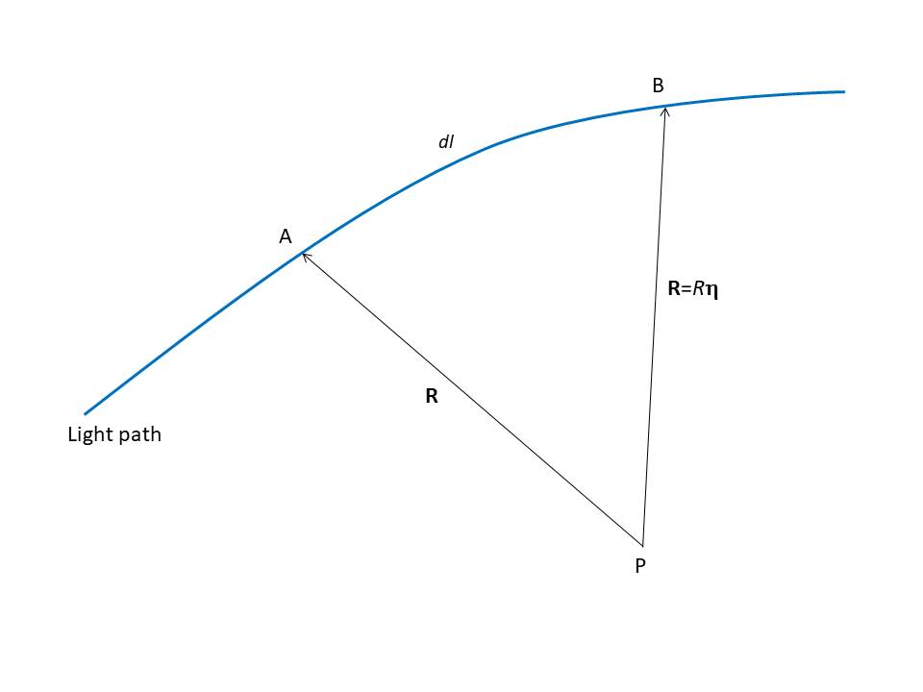

**Figure 3.** The curved path of light.

By comparing Equations (35) and (38), the resulting equation is obtained

$\frac{dτ}{dl}=\frac{η}{R}$. (39)

Equation (39) is known as Frenet-Seret’s equation [27,28].

The combination of Equations (33) and (39) gives the following equation:

$\frac{η}{R}=\frac{1}{n\left(r\right)}\left\{∇n\left(r\right)-τ\left(τ.∇n\left(r\right)\right)\right\}$. (40)

If Equation (40) is subjected to a dot operation with **η**, it will give the equation

$\frac{1}{R}=\frac{η}{n\left(r\right)}.∇n\left(r\right)$. (41)

Equations (40) and (41) are respectively referred to as the ray formation equation and the ray deflection equation [5].

Based on Equation (41), it can be deduced that the direction of wave propagation is influenced by variations in the refractive index. Specifically, as the refractive index increases, the wave undergoes a change in direction. Hence, in a homogeneous medium where *n(r)* is constant, or in free space where *n(r)*=1, so $∇n\left(r\right)=0$, the wave trajectory remains unaffected by refraction. In such cases, the bending radius *R* approaches infinity, indicating that the wave path is linear.

The light ray trajectory equation (geodesic equation) can be derived by combining Equations (28) and (33), resulting in the following form:

$\frac{d^{2}r}{dl^{2}}=\frac{1}{n\left(r\right)}\left\{∇n\left(r\right)-τ\left(τ.∇n\left(r\right)\right)\right\}$. (42)

By reviewing the Abelian U(1) gauge theory [29], it can be understood that Equation (42) incorporates the refractive index *n(r)*, which is analogous to the gauge field, the gradient of the refractive index **∇***n(r****)***, which is analogous to the field tensor, the optical force **∇***n(r)/n(r)*, which is analogous to the electromagnetic force, light rays, which are analogous to charged particles, and the role of the refractive index in altering light paths, which is analogous to the role of potential in influencing particle trajectories.

**Simulation**

The simulation of phase shifts, and trajectory of light bending, in light trajectories through a homogeneous medium (A), vacuum (B), anisotropic materials (C), and optical metamaterials (D) is presented in Figure 4 and Figure 5. In the simulation, light passes through: (A) a medium represented by a series of identical refractive index values, (B) a vacuum represented by refractive index values equal to 1, (C) anisotropic materials represented by the boundary region between two media, and (D) optical metamaterials represented by negative refractive index values, as shown in Table 1.

The simulation is based on Equation (17), Equation (39), and Equation (42), with the implementation of the numerical method described in [30]. Equation (17) can be expressed as

$φ_{i}≈{\frac{ω}{c}n}_{i}\left(r_{i}-r_{i-1}\right)$ (43)

due to

$∆=ndl≈n_{i}\left(r_{i}-r_{i-1}\right)$. (44)

Equation (41) can be approximated as

$\frac{1}{R_{i+1}}≈\frac{n_{i+1}-n_{i-1}}{2n_{i}.∆r}$, (45)

based on the simplification of Equation (41) into

$\frac{1}{R}=\frac{dn}{2ndl}$, (46)

where the central difference approximation is applied as

$\frac{dn}{dl}≈\frac{n_{i+1}-n_{i-1}}{2∆r}$. (47)

Equation (42) can further be expressed as

$r_{i+1}≈2r_{i}-r_{i-1}+\frac{{\left(∆l\right)}^{2}}{n_{i}}\left(\frac{n_{i+1}-n_{i-1}}{2∆r}\right)\left(1-τ^{2}\right)$, (48)

where

$\frac{d^{2}r}{dl^{2}}≈\left(\frac{r_{i+1}-2r_{i}+{ r}_{i-1}}{{\left(∆l\right)}^{2}}\right)$, (49)

$∇n\left(r\right)≈\left(\frac{n_{i+1}-n_{i-1}}{2∆l}\right)$, (50)

and

$τ\left(τ.∇n\left(r\right)\right)≈τ^{2}\left(\frac{n_{i+1}-n_{i-1}}{2∆l}\right)$. (51)

The graph in Figure 4 depicting the relationship between phase shift *ϕ* and propagation path length *l* can be analyzed based on the characteristics of the media through which light travels. In regions where light propagates through homogeneous media with constant refractive indices, such as vacuum or transparent materials, the phase shift remains stable or linear with respect to the path length. This behavior is evident in the regions between *l*=0 m and *l*=10 m, *l*=15 m and *l*=41 , and *l*=45 m and *l*=53 m, where *ϕ* is close to zero. These regions reflect the absence of significant disturbances or interactions, indicating stable light propagation.

In contrast, regions between *l*=10 m and *l*=11 m, as well as *l*=14 m and *l*=15 m, exhibit moderate fluctuations, suggesting interactions with anisotropic materials. These materials have refractive indices that depend on the direction of propagation or polarization of light, leading to more noticeable phase shifts. Such fluctuations can be attributed to birefringence phenomena, where light splits into two beams with different propagation speeds depending on polarization, resulting in phase variation.

Additionally, the sharp fluctuations observed in the region between *l*=42 m and *l*=44 m indicate interactions with optical metamaterials having negative refractive indices. In such materials, the wave vector and energy flow vector (Poynting vector) are oppositely directed, leading to unconventional effects like negative refraction. The significant positive phase shift followed by a sharp negative shift in this region reflects the distinctive properties of negative-index materials.

In summary, the graph illustrates the journey of light through a combination of propagation paths that include homogeneous media (stable), anisotropic materials (moderate fluctuations), and optical metamaterials (drastic fluctuations). This analysis provides insights into the complex interactions of light with various types of media, which are particularly relevant in advanced optical systems such as interferometers, metamaterials, or integrated optical devices.

The graph in Figure 5 shows the relationship between the inverse radius of curvature 1/*R* and the propagation path length *l*, providing insights into the wavefront behavior as light interacts with different media. In regions where light propagates through homogeneous media or vacuum—specifically *l*=0 m to *l*=10 m, *l*=15 m to *l*=41 m, and l=45 m to *l*=53 m, the 1/*R* value remains constant, indicating a nearly planar wavefront with no significant curvature changes.

In contrast, regions between *l*=10 m and *l*=11 m, and *l*=14 m and *l*=15 m, exhibit ripple in 1/*R*, suggesting interactions with anisotropic materials. These fluctuations indicate perturbations in the wavefront curvature, likely caused by birefringence or directional-dependent refractive indices within the material, momentarily distorting the wavefront.

The most pronounced behavior is observed in the region between *l*=42 m and *l*=44 m, where 1/*R* not only exhibits sharp ripples but also becomes negative. This curvature inversion is a hallmark of optical metamaterials with negative refractive indices, where the wavefront exhibits unusual effects such as reverse focusing or negative curvature due to the opposition of phase velocity and energy flow.

Together with the phase shift analysis, this graph highlights the distinct interactions of light with different media along the propagation path. Homogeneous regions are characterized by stable and planar wavefronts, anisotropic materials introduce moderate perturbations, and optical metamaterials cause sharp ripples, demonstrating their unique optical properties.

|  |
| --- |
| D  A, B  A, B  A, B  C  **Figure 4.** The phase shift of light through a homogeneous medium (A), vacuum (B), anisotropic materials (C), and optical metamaterials (D). |
| A, B  A,B  A, B  D  C |
| **Figure 5.** The trajectory of light bending through a homogeneous medium (A), vacuum (B), anisotropic materials (C), and optical metamaterials (D). |
| |  |  |  |  |  |  |  |  | | --- | --- | --- | --- | --- | --- | --- | --- | | **Table 1.** Simulation results for*τ* = 0.9. | | | |  |  |  |  | | ***n* ( *r* )** | ***l* (m)** | **1/*R* (m-1)** | ***ϕ* (m)** | ***n* ( *r* )** | ***l* (m)** | **1/*R* (m-1)** | ***ϕ* (m)** | | 1 | 0 | 0.000000001 | 0 | 1 | 27 | 0.000000001 | 0.3325 | | 1 | 1 | 0.000000001 | 0 | 1 | 28 | 0.000000001 | 0.3325 | | 1 | 2 | 0.000000001 | 0 | 1 | 29 | 0.000000001 | 0.3325 | | 1 | 3 | 0.000000001 | 0 | 1 | 30 | 0.000000001 | 0.3325 | | 1 | 4 | 0.000000001 | 0 | 1 | 31 | 0.000000001 | 0.3325 | | 1 | 5 | 0.000000001 | 0 | 1 | 32 | 0.000000001 | 0.3325 | | 1 | 6 | 0.000000001 | 0 | 1 | 33 | 0.000000001 | 0.3325 | | 1 | 7 | 0.000000001 | 0 | 1 | 34 | 0.000000001 | 0.3325 | | 1 | 8 | 0.25 | 0 | 1 | 35 | 0.000000001 | 0.3325 | | 1 | 9 | 0.166666667 | 0.07125 | 1 | 36 | 0.000000001 | 0.3325 | | 1 | 10 | 0.000000001 | 0.19 | 1 | 37 | 0.000000001 | 0.3325 | | 1.5 | 11 | 0.000000001 | 0.30875 | 1 | 38 | 0.000000001 | 0.3325 | | 1.5 | 12 | -0.166666667 | 0.4275 | 1 | 39 | -1.25 | 0.3325 | | 1.5 | 13 | -0.25 | 0.3325 | 1 | 40 | 0.833333333 | -0.1425 | | 1.5 | 14 | 0.000000001 | 0.3325 | 1 | 41 | 0.000000001 | -0.02375 | | 1 | 15 | 0.000000001 | 0.3325 | -1.5 | 42 | -0.833333333 | 0.095 | | 1 | 16 | 0.000000001 | 0.3325 | -1.5 | 43 | 1.25 | -0.30083 | | 1 | 17 | 0.000000001 | 0.3325 | -1.5 | 44 | 0.000000001 | -0.30083 | | 1 | 18 | 0.000000001 | 0.3325 | 1 | 45 | 0.000000001 | -0.30083 | | 1 | 19 | 0.000000001 | 0.3325 | 1 | 46 | 0.000000001 | -0.30083 | | 1 | 20 | 0.000000001 | 0.3325 | 1 | 47 | 0.000000001 | -0.30083 | | 1 | 21 | 0.000000001 | 0.3325 | 1 | 48 | 0.000000001 | -0.30083 | | 1 | 22 | 0.000000001 | 0.3325 | 1 | 49 | 0.000000001 | -0.30083 | | 1 | 23 | 0.000000001 | 0.3325 | 1 | 50 | 0.000000001 | -0.30083 | | 1 | 24 | 0.000000001 | 0.3325 | 1 | 51 | 0.000000001 | -0.30083 | | 1 | 25 | 0.000000001 | 0.3325 | 1 | 52 | 0.000000001 | -0.30083 | | 1 | 26 | 0.000000001 | 0.3325 | 1 | 53 | 0.000000001 | -0.30083 | |

**Conclusion**

This study revisits the formulation of geometrical optics and proposes a possible refinement using a gauge-theoretic approach, allowing for the derivation of phase equations and precise modeling of light ray trajectories. Through extensive simulations across diverse optical media, the method showcases its versatility and powerful predictive ability, offering a solid framework for exploring and understanding complex optical phenomena.

**References**

[1] M. Born and E. Wolf, *Principles of optics*, 7th ed. Cambridge University Press, 1999.

[2] E. Hecht, *Optics*, 4th ed. Pearson Education, Inc., 2002.

[3] B. D. Guenther, *Modern Optics Simplified*, 1st ed. Oxford University Press, 2020.

[4] A. V. Fedorov, C. A. Stepa, A. V. Korolkova, M. N. Gevorkyan, and D. S. Kulyabov, “Methodological derivation of the eikonal equation,” *Discret. Contin. Model. Appl. Comput. Sci.*, vol. 31, no. 4, pp. 399–418, 2023, doi: 10.22363/2658-4670-2023-31-4-399-418.

[5] L. D. Landau and E. M. Lifshitz, *Electrodynamics of Continuous Media*, 2nd ed. Pergamon Press, 1984.

[6] K. V Shajesh, “Eikonal Approximation.” [Online]. Available: https://www.nhn.ou.edu/~shajesh/eikonal/sp.pdf

[7] A. F. Ranada, “Topological electromagnetism,” *J. Phys. 4 Math. Gen*, vol. 25, pp. 1621–1641, 1992.

[8] F. Liu and J. Li, “Gauge field optics with anisotropic media,” *Phys. Rev. Lett.*, vol. 114, no. 10, Mar. 2015, doi: 10.1103/PhysRevLett.114.103902.

[9] D. Delphenich, “On geodesics of gradient-index optical metrics and the optical-mechanical analogy,” 2020. [Online]. Available: https://arxiv.org/abs/2002.04390

[10] D. K. Sharma and S. K. Pathak, “Propagation characteristics of an extremely anisotropic metamaterial loaded helical guide,” *Opt. Express*, vol. 24, no. 26, p. 29521, Dec. 2016, doi: 10.1364/oe.24.029521.

[11] M. Hadi and S. Muliyono, “Gauge Theory in a Vacuum Space-time,” *Indones. Phys. Rev.*, vol. 7, no. 1, pp. 143–151, 2024, doi: 10.29303/ip.

[12] S. Weinberg, *The Quantum Theory of Fields Volume I Foundations*. 1995.

[13] I. J. Aitchison and A. J. Hey, *Gauge Theories Particle Physics, VOLUME 1 From Relativistic Quantum Mechanics to QED*. 2013.

[14] S. Alsid and M. Serna, “Unifying Geometrical Representations of Gauge Theory,” *Found. Phys.*, vol. 45, no. 1, pp. 75–103, Jan. 2015, doi: 10.1007/s10701-014-9841-x.

[15] D. E. Ruiz and I. Y. Dodin, “Lagrangian geometrical optics of nonadiabatic vector waves and spin particles,” *Phys. Lett. Sect. A Gen. At. Solid State Phys.*, vol. 379, no. 38, pp. 2337–2350, Aug. 2015, doi: 10.1016/j.physleta.2015.07.038.

[16] P. Fontana, “Quantum simulations of gauge theories and topological phases,” 2021. [Online]. Available: https://iris.sissa.it/retrieve/323d4c9d-5fd0-45a4-9186-758b91a12ed4/thesis_v3__external_referees_corrections_.pdf

[17] K. H. Yang, “Gauge Transformations and Quantum Mechanics Gauge Invariant Interpretation of Quantum Mechanics,” *Ann. Phys. (N. Y).*, vol. 96, pp. 62–96, 1976.

[18] M. J. D. Hamilton, *Mathematical Gauge Theory*. Springer International Publishing, 2017.

[19] Y. Chen *et al.*, “Non-Abelian gauge field optics,” *Nat. Commun.*, vol. 10, no. 1, Dec. 2019, doi: 10.1038/s41467-019-10974-8.

[20] S. I. Maslovski and H. Mariji, “Envelope Dyadic Green’s Function for Uniaxial Metamaterials,” Feb. 2018. [Online]. Available: http://arxiv.org/abs/1802.05899

[21] C. A. Dartora *et al.*, “Lagrangian-Hamiltonian formulation of paraxial optics and applications: Study of gauge symmetries and the optical spin Hall effect,” *Phys. Rev. A - At. Mol. Opt. Phys.*, vol. 83, no. 1, Jan. 2011, doi: 10.1103/PhysRevA.83.012110.

[22] A. H. Gevorgyan and M. S. Rafayelyan, “Light propagation in anisotropic metamaterials. I. Dispersion surfaces,” *J. Contemp. Phys.*, vol. 48, no. 6, pp. 276–284, 2013, doi: 10.3103/S1068337213060042.

[23] T. Honjo, K. Inoue, and H. Takahashi, “Differential-phase-shift quantum key distribution experiment with a planar light-wave circuit Mach–Zehnder interferometer,” *Opt. Lett.*, vol. 29, no. 23, p. 2797, 2004, doi: 10.1364/ol.29.002797.

[24] S. K. Debnath and M. P. Kothiyal, “Experimental study of the phase-shift miscalibration error in phase-shifting interferometry: Use of a spectrally resolved white-light interferometer,” *Appl. Opt.*, vol. 46, no. 22, pp. 5103–5109, 2007, doi: 10.1364/AO.46.005103.

[25] J. Aizenberg, J. A. Rogers, K. E. Paul, and G. M. Whitesides, “Imaging profiles of light intensity in the near field: applications to phase-shift photolithography,” *Appl. Opt.*, vol. 37, no. 11, p. 2145, 1998, doi: 10.1364/ao.37.002145.

[26] M. L. Boas, *Mathematical Methods in Physical the Physical Sciences*, vol. 57, no. 1. John Wiley & Son, 2006. doi: 10.2307/2275199.

[27] M. Masujima, *Applied Mathematical Methods in Theoretical Physics*. Wiley-VCH Verlag GmbH&Co.KGaA, 2005. doi: 10.1002/9783527627745.

[28] M. R. Spiegel, *Vector Analysis and an Introduction to Tensor Analysis*. McGraw-Hill, Inc., 1959.

[29] D. Tong, “Gauge Theory,” 2018. doi: 10.1007/978-3-319-14765-9_14.

[30] S. S. Sastry, *Introductory Methods of Numerical Analysis*, Fifth., vol. 4, no. 1. PHI Learning Private Limited, New Delhi, 2012.