**THE IDENTIFICATION OF MICROPLASTICS IN KARANG MUMUS AND KARANG ASAM KECIL RIVER ESTUARY, SAMARINDA**

Searphin Nugroho, Dwi Ermawati Rahayu,Yarinse Seleng, Ika Meicahayanti, Ibrahim

Departement of Environmental Engineering, Mulawarman University. Jl. Sambaliung No. 9 Samarinda.

E-Mail: searphin91@gmail.com

Article accepted : November, 09th 2022. Revision accepted: .................... 20xx.

**ABSTRACT**

The downstream of Mahakam River that crosses Samarinda City is surrounded by densely populated urban areas and many activities. This area also has several small rivers or tributaries, such as the Karang Mumus and Karang Asam Kecil River. A higher abundance of microplastics is often found in small rivers in urban areas. It is necessary to research microplastic pollution. River water sampling was carried out using an integrated sampling method on both sides and the middle of the estuary. Furthermore, the sample passes through the first filtration process, removal of organic substances using H2O2, separation with a density separator, and second filtration. Microplastic analysis with a microscope was carried out to determine the size, shape, and color. FTIR analysis to determine the type of microplastic polymer. The results showed that the dominant shape of microplastic found is the type of fiber, but fragments and films are also found. The size of the microplastic that dominates is microplastic measuring 25-250µm. While the black color was found more in all samples, but also red, blue, and transparent. Nylon, nitrile, and polyethylene terephthalate (PETE) were the polymers found. The abundance of microplastics is known to decrease with the depth of sampling.

**Key words:** Abundance of microplastics, Estuary, Microplastic, River, Samarinda.

**ABSTRAK**

Bagian hilir Sungai Mahakam yang melintasi Kota Samarinda dikelilingi oleh kawasan perkotaan yang padat penduduk. Di daerah ini juga terdapat beberapa sungai kecil atau anak sungai seperti Sungai Karang Mumus dan Karang Asam Kecil. Karena sungai-sungai kecil di perkotaan sering ditemukan konsentrasi mikroplastik yang lebih tinggi, maka perlu dilakukan penelitian tentang pencemaran mikroplastik. Pengambilan sampel air sungai dilakukan dengan menggunakan metode sampling terpadu pada kedua sisi sungai dan tengah sungai. Selanjutnya sampel melewati proses penyaringan pertama, penghilangan zat organik menggunakan H2O2, pemisahan dengan pemisah densitas, dan penyaringan kedua. Analisis mikroplastik visual dengan mikroskop dilakukan untuk mengetahui ukuran, bentuk, dan warna, serta analisis FTIR untuk mengetahui jenis polimer mikroplastik. Hasil penelitian menunjukkan bahwa bentuk mikroplastik yang dominan ditemukan adalah jenis serat, tetapi juga ditemukan fragmen dan film. Ukuran mikroplastik yang mendominasi adalah mikroplastik berukuran 25 m-250 m. Sedangkan warna hitam lebih banyak ditemukan pada semua sampel, tetapi juga ditemukan warna merah, biru, dan transparan. Jenis polimer yang ditemukan adalah nilon, nitril, dan polietilen tereftalat (PETE). Kelimpahan mikroplastik diketahui menurun dengan kedalaman pengambilan sampel.

**Kata kunci:** Kelimpahan mikroplastik, Mikroplastik, Muara sungai, Samarinda, Sungai.

**INTRODUCTION**

As the most important river for people's lives in East Kalimantan, the Mahakam River is the place for various activities such as transportation, household, restaurants, industry, plantation activities, and so on (Lestari et al., 2021). This is no exception in Samarinda City, the capital of East Kalimantan Province, which is located downstream of the Mahakam River. According to the research by Warsilan (2019), the land use in Samarinda City changes quite drastically from 2000 until 2016 to accommodate its citizens’ need for settlements and housing. Thus, making Samarinda City a densely populated area in Mahakam’s watershed.

Within Samarinda City itself, there are several small rivers that flow to Mahakam River, such as Karang Mumus and Karang Asam Kecil River. In Karang Mumus River, there are several activities within its riversides such as agriculture and farm in the upstream, along with settlements, market, hospital, hotel, etc. in the downstream (Pramaningsih et al., 2017). As for Karang Asam Kecil River, the land uses in the riversides are such as coal mining in the upstream and settlements in the downstream (Budiman, 2018).

Based on the previous research by Pramaningsih et al. (2017), the water quality from Karang Mumus River is exceeding the quality standards from Local Regulation of East Kalimantan No. 2, 2011, which caused by the activities in its riverbanks, such as household activities that are disposing domestic wastes into the river. According to Jambeck et al. (2015), domestic waste usually, consists of plastic waste or slowly degraded waste. The plastic waste within the stream, although will take a long time to fully degrade, still can degrade into smaller pieces of plastic called microplastic (Yunanto et al., 2021). The spread of microplastics in the water has become a serious ecological problem for the aquatic ecosystem. According to Mardiyana & Kristiningsih (2020), the presence of microplastics in the surface water could accumulate in the aquatic organism. Wright et al. (2013) added that accumulated microplastics in the aquatic biota caused several negative impacts such as digestive tract blockage, blockage of enzyme production, stunted growth, a decrease of steroid hormone, and failed reproduction.

Several previous studies show that microplastics can be found in the estuary, such as the Kendal River (Hanif et al., 2021) and the Sei Sikambing River (Hasibuan et al., 2020). Thus, the presence of microplastics in the Karang Mumus and Karang Asam Kecil River Estuary is also possible. So far, the research on microplastics in Samarinda City is still limited, especially on the estuary of tributaries. Therefore, the purposes of this study are to identify the abundance of microplastics in the Karang Mumus and Karang Asam Kecil Estuary based on their shape, size, color, and polymer type, along with to analyze the influence of river depth with the abundance of microplastics.

**METHODS**

**Research Location**

This research is carried out in two locations, Karang Mumus River Estuary and Karang Asam Kecil River Estuary, Samarinda. A densely urban area on the riverside of these locations is the reasoning behind these selections, as stated in the previous section. The visualization of the research locations can be seen in Figure 1.

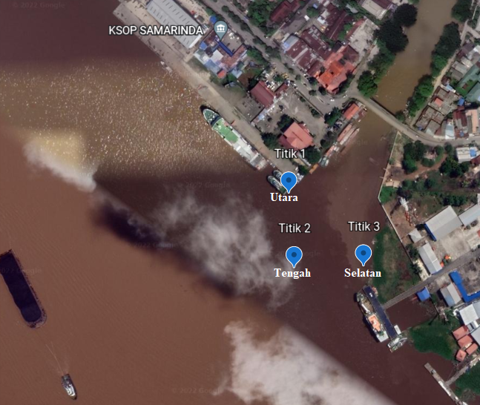

(a) (b)

**Figure 1.** The research location of microplastic identification in: a) Karang Mumus River Estuary; b) Karang Asam Kecil River Estuary

**Research Procedures**

*Preparation stage*

Before starting the research, a number of equipment and materials need to be prepared first. The equipment needed in this study are sample bottles, cool box, oven, glass funnel, SZP microscope, beaker glass 500 mL. hot plate, GPS, aluminum foil, water sampler, vacuum pump, analytical weight balance, latex hose, spatula, and stirrer. The materials needed are Fe (II) solution 0,5 M, H2O2 solution 30%, NaCl powder, distilled water, and river water samples.

*Determining the sampling plots*

The determination of plots at the research sites was carried out through field surveys and observations using Google Earth. The points that have been selected are then recorded in the coordinates using GPS. In general, there are three sampling plots at each location, namely at the north, south, and middle plots of the river mouth.

*River water sampling*

Water sampling was carried out based on SNI 03-7016-2004, where the samples were taken using the integrated sampling and grab sampling method using a water sampler about 500 ml. Sampling in the northern and southern plots was carried out based on a depth of 0.5 meters, 1 meter, and 1.5 meters, while in the middle plot it was carried out at the water's surface. The cycle was repeated 1 time. The sample that has been taken is then put into a 1-liter glass sample bottle and labeled according to the plot of water collection. Then the water is stored in a cool box and analyzed in the laboratory.

*First stage separation using nylon net*

The next step is to filter the water using a 25 m nylon filter and a vacuum pump. At this stage, all solids contained in the samples are separated from the water. The solids contained in this filter are a mixture of microplastics and impurities.

*Organic matter elimination*

The sample on a nylon filter was then transferred to a beaker with the help of distilled water. Then, the sample was given a solution of 20 mL of 0.05 M Fe (II) and 20 mL of 30% H2O2 to dissolve the organic matter and the sample was left at room temperature for 5 minutes. Fe (II) serves as a catalyst in this process. Next, the beaker glass was given a stir bar and then covered with aluminum foil and heated on a hotplate with a temperature of 75°C. At this stage, the solution reacts and releases bubbles. When it is seen that there is a potential for the solution to react until it comes out of the beaker glass, distilled water is added to slow down the reaction.

*Further separation using density separator*

After the organic contaminants were removed, the sample was added with 6 g of NaCl per 20 ml and stirred using a magnetic stirrer while heated at 75°C until dissolved to increase the density value and other materials other than microplastics could settle (Masura et al., 2015). The next step is to put the sample into the density separator. The sample is left for 24 hours so that the solid settles, then the solid that settles on the bottom of the tool is discarded. The part that is discarded is the solid part that settles. The remaining water and microplastic samples were transferred to a beaker glass and went to the next stage (Sharma, 2019).

*Second stage separation using nylon net*

The second filtering stage was carried out using a 25 m nylon filter. The purpose of this second filtering step is to separate the microplastic from the solution. The difference in the size of the nylon sieve was used to determine the size variation of the microplastic contained in the sample. The filter was then covered with aluminum foil and observed using a microscope.

**Data Analysis**

In this research, there are 3 (three) analysis which are: a) the identification of microplastics using Student Zeiss Primo star microscope for determining the shape, size, and color of microplastics; b) the identification of microplastics using FTIR spectrophotometer for determining the polymer type of the microplastics; and c) the relationship between the abundance of microplastics with the river depth.

To facilitate the analysis in points a and c, the determination of the abundance of microplastics from each sample taken was carried out. The formula used for calculating the abundance of microplastics can be seen on the Equation 1.

The abundance of microplastics = $\frac{The number of microplastics in the sampled water (particle)}{The volume of sampled water (litre)}$……………….. (1)

**RESULT AND DISCUSSION**

.

**The Amount of Microplastics in All Samples**

From the samples taken from research locations, there are several processes to separate the microplastics from the water and other contaminants. After that, the microplastics from each sampled river water were counted to determine the abundance of microplastics, along with the identification of shape, size, and color using SZP microscope. For the abundance of microplastics from each spot within the research locations, it can be seen at Table 1.

**Table 1.** The abundance of microplastics from each samples taken

|  |  |  |  |  |  |  |  |
| --- | --- | --- | --- | --- | --- | --- | --- |
| **Location** | **The Abundance of Microplastics (particle/litre)** | | | | | | |
| **North** | | | **South** | | | **Middle** |
| **0.5 m** | **1 m** | **1.5 m** | **0.5 m** | **1 m** | **1.5 m** | **Surface** |
| Karang Mumus River Estuary | 68 | 54 | 50 | 62 | 50 | 40 | 96 |
| Karang Asam Kecil River Estuary | 48 | 38 | 34 | 50 | 34 | 30 | 76 |

Based on Table 1, there are 14 samples taken from all research locations, which means that there are about 7 (seven) samples from each location. The highest number of microplastics’ abundance in Karang Mumus River Estuary is in the middle plot with 96 particles/l, while the lowest one is in the south plot, precisely 1,5 m below surface water, about 40 particles/l. The same trend also happened in the Karang Asam Kecil River Estuary, where the highest microplastics’ abundance is in the middle plot with 76 particles/l and the lowest one is in-depth of 1,5 m in the south plot, with 30 particles/l.

Both locations consist of 3 (three) plots: north, south, and middle. In the north and south plots, the sampling was done in 3 different levels of river depth which are 0,5, 1, and 1,5 m from the surface water. Meanwhile, in the middle plots, the sampling was only conducted on the surface (around 0,5 m) because of the turbulence in the estuaries, thus it was difficult to sample the river water at the deeper level.

**The Analysis of Microplastics based on the Shape**

Based on the identification of microplastics that separated from the samples, there are 3 (three) shape types of microplastics found in Karang Mumus and Karang Asam Kecil River Estuary. Those are fiber, film, and fragment-shaped microplastics. As for the visualization of those shapes found in research locations, it can be seen on the Figure 2.

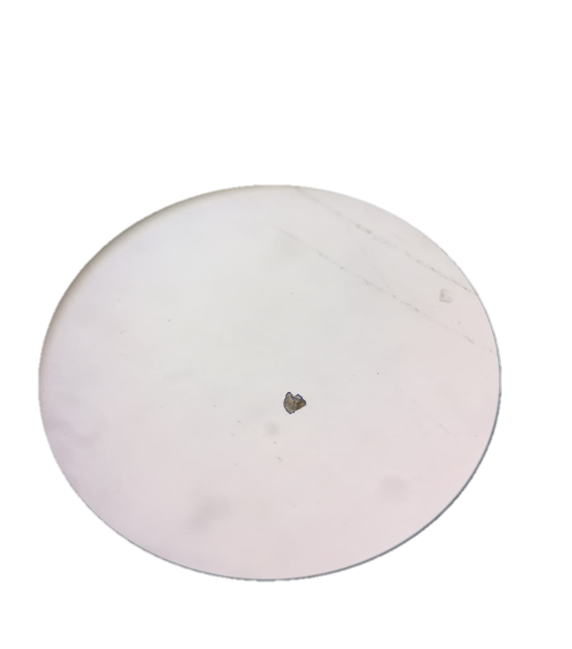**

(a) (b) (c)

**Figure 2.** The visualization of microplastics’ shapes from Karang Mumus and Karang Asam River Estuary: (a) fiber; (b) film; (c) fragment

As stated in the previous sub-section, the identification of microplastic types was done by using an SZP microscope along with counting the abundance of those while classifying into the shape, size, and color type found in each sample. After that, all samples counted from each location were calculated to determine the average of microplastics’ abundance from Karang Mumus and Karang Asam Kecil River Estuary. As for the shape types, the microplastic categorization results in both locations can be seen in Figure 3.

**Figure 3.** The microplastic categorization from research location based on the shape

It can be seen in Figure 3 that the fiber type of microplastics dominated in both locations, which are averaging about 35.14 particles/l in Karang Mumus River Estuary and 25.43 particles/l in Karang Asam Kecil River Estuary. Then, it is followed by film type and fragment type in both research locations. The domination of the fiber type in Karang Mumus and Karang Asam Kecil River Estuary is caused by the activities within those locations in the riversides, such as the resident activities, port activities, and fishing activities that are using nets. This is supported by the research by Suriyanto et al. (2020) that found the existence of household, port, and fishing activities tend to generate fiber type of microplastics. Also, according to Dewi et al. (2015), fishing activities generate fiber type of microplastics because the basis for making fishing gear such as cloth, nets, rigging, and fishing boat wastes are scattered in open waters.

**The Analysis of Microplastics based on the Size**

Similar to the shape identification, identifying the size of microplastics was done by using an SZP microscope, which gave results of 5 (five) group sizes. The ranges are from 25-250 μm, 250-500 μm, 500-1,000 μm, 1,000-2,500 μm, and 2,500-5,000 μm. The microplastic categorization results by the size in both locations can be seen in Figure 4.

**Figure 4.** The microplastic categorization from research location based on the size

Based on Figure 4, it can be seen that the 25-250 μm range size of microplastics dominated in both locations, which are averaging about 35.14 particles/l in Karang Mumus River Estuary and 25.43 particles/l in Karang Asam Kecil River Estuary. Then, it is followed by the range size of 250-500, 500-1,000, 1,000-2,500, and 2,500-5,000 μm in Karang Mumus River Estuary, while in Karang Asam Kecil River Estuary it is followed by the range size of 500-1,000, 250-500, 1,000-2,500, and 2,500-5,000 μm.

The domination of the 25-250 μm range size in Karang Mumus and Karang Asam Kecil River Estuary is related to the low-density characteristic of the small-sized microplastics. According to Horton et al. (2017), microplastics that have a smaller density tend to be lighter and are located on the water surface and microplastics that have a higher density tend to be in the water column or settle in sediments

**The Analysis of Microplastics based on the Color**

There are 4 (four) color types of microplastics found in Karang Mumus and Karang Asam Kecil River Estuary, which are black, colorless, blue, and red. The black color is found on the fiber and fragment-shaped microplastics, the colorless ones are found on film-shaped microplastics, the blue ones are found on fiber and film-shaped microplastics, and the red ones are found on fiber-shaped microplastics. The microplastic categorization results by the color in both locations can be seen in Figure 5.

It can be seen in Figure 5 that the black-colored microplastics dominated in both locations, which are averaging about 36.86 particles/l in Karang Mumus River Estuary and 29.71 particles/l in Karang Asam Kecil River Estuary. Then, it is followed by the blue, colorless, and red-colored microplastics in Karang Mumus River Estuary, while in Karang Asam Kecil River Estuary it is followed by the colorless, blue, and red-colored microplastics. The domination of the black-colored microplastics in Karang Mumus and Karang Asam Kecil River Estuary could be caused by several factors, such as the exposure duration of microplastics under sunlight (Azizah et al, 2020), the result of polypropylene plastic degradation (Widiyatmoko et al, 2016), and the presence of organic matter in the water which absorbed into the microplastics (Hiwari et al, 2019).

**Figure 5.** The microplastic categorization from research location based on the color

**The Polymer Type of Microplastics**

The identification of microplastics' polymer type was done through FTIR analysis, although only some portion of each plot can be analyzed. The results from FTIR analysis are the wavelength data from each microplastic used for determining the polymer type by matching those with the reference by Jung et al. (2018). The result of the identification can be seen in Table 2.

**Table 2.** The results of microplastics’ polymer type identification

|  |  |  |  |
| --- | --- | --- | --- |
| Sample | Wavelength | Absorption Band  (Jung et al., 2018) | Polymer Type |
| Karang Mumus (North) | 3313.85 | 3298 | *Nylon* |
| 1636.26 | 1605 | *Nitrile* |
| Karang Mumus  (Middle) | 3312.60 | 3298 | *Nylon* |
| 1636.22 | 1605 | *Nitrile* |
| Karang Mumus  (South) | 3324.01 | 3298 | *Nylon* |
| 1036.10 | 1605 | *Polyethylene terephthalate* (PETE) |
| Karang Asam  (North) | 3313.85 | 3298 | *Nylon* |
| 1638.28 | 1605 | *Nitrile* |
| Karang Asam  (Middle) | 3312.60 | 3298 | *Nylon* |
| 1315.22 | 1605 | *Polyethylene terephthalate* (PETE) |
| Karang Asam (South) | 3324.01 | 3298 | *Nylon* |
| 1636.10 | 1605 | *Nitrile* |

According to Table 2, it can be seen that the polymer types found on Karang Mumus and Karang Asam River Estuary are the same, which are consisting of nylon, nitrile, and polyethylene terephthalate (PETE). Narang et al. (2011) explained that nylon, especially nylon membranes, are widely used as polymers in the textile and plastics industry because of their good mechanical, thermal, and chemical properties. Also, nylon membranes are resistant to high pH, high temperatures and have a small pore size distribution, and tend to float on the surface of the water. According to Garland (2013), nitrile is a polymer that can be used in latex and medical gloves. Gloves made of nitrile are increasingly being used as an alternative to gloves that can cause allergies (latex). As for the PETE, it is often used as disposable bottles or often also used in the form of films, but this material is mostly used in the form of fiber (Chu et al, 2021).

**The Relationship between River Depth with The Abundance of Microplastics**

In this section, the analysis was done by comparing microplastics’ abundance within the plot, especially the plot that has 3 (three) sampling points based on the river depth, which are 0.5, 1, and 1.5 m. Because of that, the middle plots are not included in this analysis. As for the result of the correlation, it can be seen in Figure 6.

Figure 6. The graphic of relationship between the river depth with the abundance of microplastics

It can be seen in Figure 6 that the abundance of microplastics is lower along with the increase in the river depth. They are consistently found in both research locations. This phenomenon is related to the abundance of small-sized microplastics found in Karang Mumus and Karang Asam Kecil River Estuary that dominated in those places, especially with the range size of 25-250 μm. Microplastics that have a smaller density tend to be lighter and are located on the water surface, while the microplastics that have a higher density tend to be in the water column or settle in sediments (Horton et al, 2017).

CONCLUSION

Based on the results found in this study, the conclusions that can be drawn are as follows:

* The type of microplastics found in Karang Mumus and Karang Asam River Estuary are fiber, film, and fragment where the fiber type dominates. For the size of microplastics, the size of 25-250 μm dominates in both locations. As for the color, there are black (fiber & fragment), red (fiber), colorless (film), and blue (fiber & film) in both locations, which dominated by black-colored microplastics.
* The polymer type of microplastics found in Karang Mumus and Karang Asam River Estuary are nylon, nitrile, and Polyethylene terephthalate (PETE).
* The abundance of microplastics is lower along with the increase of the river depth

**ACKNOWLEDGEMENTS**

The authors are grateful to the Faculty of Engineering, Mulawarman University, for providing the financial support needed to complete this research.

**REFERENCES**

Azizah P, Ridlo A, Suryono CA. 2020. Mikroplastik pada Sedimen di Pantai Kartini Kabupaten Jepara Jawa Tengah. Journal of Marine Research, 9(3): 326–332.

Budiman PW. 2018. Evaluation of Land Using in Sub Watershed of Karang Asam Kecil. Riset Pembangunan, 1(1): 19-35.

Chu J, Xingyun H, Linghao K, Ningning W, Suhuan Z, Mengchang H, Wei O, Xitao L, Chunye L. 2021. Dynamic Flow and Pollution of Antimoy from Polyethylene Terephthalate (PET) Fibers in China, Science of The Total Environment, 771(2021).

Dewi IS, Ritonga AAB, Ramadhan I. 2015, Distribusi mikroplastik pada sedimen di Muara Badak, Kabupaten Kutai Kartanegara. Depik, 4(3): 121–131.

Garland KV. 2013. The benefits of nitrile. J Professional Excellence, 11(9).

Hanif KH, Suprijanto J, Pratikto I. 2021. Identifikasi Mikroplastik di Muara Sungai Kendal, Kabupaten Kendal. Journal of Marine Research, 10(1): 1–6.

Hasibuan NH, Suryati I, Leonardo R, Risky A, Ageng P, Addauwiyah R. 2020. Analisa Jenis, Bentuk Dan Kelimpahan Mikroplastik Di Sungai Sei Sikambing Medan. Jurnal Sains Dan Teknologi: Jurnal Keilmuan Dan Aplikasi Teknologi Industri, 20(2).

Hiwari H, Purba NP, Ihsan YN, Yuliadi LPS, Mulyani PG. 2019. Kondisi sampah mikroplastik di permukaan air laut sekitar Kupang dan Rote, Provinsi Nusa Tenggara Timur. In: Prosiding Seminar Nasional Masyarakat Biodiversitas Indonesia, 5(2): pp. 165-171. Universitas Sebelas Maret Surakarta, Surakarta.

Horton AA, Alexander W, David J, Spurgeon EL, Claus S. 2017. Microplastic in Freshwater and Terrestrial Environment: Evaluating the Current Understanding to Identify the Knowledge Gaps and Future Research Priorities. Science of The Total Environment, 586: 127-141.

Jambeck JR, Geyer R, Wilcox C, Siegler TR, Perryman M, Andrady A, Narayan R, Law KL. 2015. Plastic Waste Inputs from Land into the Ocean. Science, 347(6223): 768-771.

Jung MR, Horgen FD, Orski SV, Rodriguez C V, Beers KL, Balazs GH, Jones TT, Work TM, Brignac KC, Royer S, Hyrenbach KD, Jensen BA, Lynch JM. 2018. Validation of ATR FT-IR to Identify Polymers of Plastic Marine Debris, Including those Ingested by Marine Organisms. Marine Pollution Bulletin, 127: 704-716.

Lestari VD, Suyitno, Siringoringo M. 2021. Analisis Faktor-Faktor Yang Berpengaruh Terhadap Pencemaran Air Sungai Mahakam Menggunakan Pemodelan Geographically Weighted Logistic Regression Pada Data Dissolved Oxygen. EKSPONENSIAL, 12(1): 37-46.

Mardiyana M, Kristiningsih A. 2020. Dampak Pencemaran Mikroplastik di Ekosistem Laut terhadap Zooplankton: Review. Jurnal Pengendalian Pencemaran Lingkungan (JPPL), 2(1): 29-36.

Masura J, Baker J, Foster G, Arthur C. 2015. Laboratory methods for the analysis of microplastics in the marine environment: recommendations for quantifying synthetic particles in waters and sediments. NOAA Technical Memorandum NOS-OR&R-48. 39 pp.

Narang J, Chauhan N, Singh A, Pundir CS. 2011. A Nylon Membrane Based Amperometric Biosensor for Polyphenol Determination. Journal of Molecular Catalysis B: Enzymatic, 276-281.

Pramaningsih V, Suprayogi S, Purnama ILS. 2017. Analysis Spatial Distribution of Water Quality in Karang Mumus River, Samarinda, Kalimantan Timur. Pengelolaan Sumberdaya Alam dan Lingkungan, 7(3): 211-218.

Sharma R. 2019. Experimental analysis of microplastics in beach sediment samples by density separation and microscopic examination. Degree Thesis. 48 pp.

Suriyanto. Amin B, Nedi S. 2020. Distribusi Mikroplastik pada Air Laut di Pesisir Barat Karimun Provinsi Kepulauan Riau. Berkala Perikanan Terubuk, 5(3).

Warsilan. 2019. The Impact of Land Use Changes to Water Absorbtion Ability (Case: Kota Samarinda). Pembangunan Wilayah dan Kota, 1(1): 69-82.

Widiyatmoko H, Purwaningrum P, Arum FP. 2016. Analisis Karakteristik Sampah Plastik Di Permukiman Kecamatan Tebet Dan Alternatif Pengolahannya. Indonesian Journal of Urban and Environmental Technology, 7(1): 24–33.

Wright SL, Thompson RC, Galloway TS. 2013. The physical impacts of microplastics on marine organisms: a review. Environmental Pollution, 178: 483-492.

Yunanto A, Sarasita D, Yona D. 2021. Analisis Mikroplastik pada Kerang Kijing (Pilsbryoconcha exilis) di Sungai Perancak, Jembrana, Bali. Journal of Fisheries and Marine Research, 5(2): 445-451.