Comparison of Ergonomic Evaluation Tools (AULA and RULA) for Assessing Work-Related Musculoskeletal Disorders (WMSDs) in Oyster Mushroom Farmers

(Case Study of Oyster Mushroom Farms in Lempake Samarinda)

Theresia Amelia Pawitra1,a), Lina Dianati Fathimahhayati2,b), Mayestika Ayuni Fariza3, c)

* Emails: a)[triciapawitra@gmail.com](mailto:triciapawitra@gmail.com), b)[linadianatif@ft.unmul.ac.id](mailto:linadianatif@ft.unmul.ac.id), c)[mayestikayuniii@gmail.com](mailto:mayestikayuniii@gmail.com)

1,2,3Department of Industrial Engineering, University of Mulawarman

Jalan Sambaliung No.9, Kampus Gunung Kelua, Samarinda, Indonesia

**Abstract.** Agriculture is a challenging sector in which farmers have the potential risk of musculoskeletal disorders, since their working conditions require awkward static postures. Likewise, oyster mushroom farmers suffered from musculoskeletal disorders in most agricultural work. Oyster mushroom cultivation activities mostly use the upper extremities segments and involve stooped posture and repetitive manual tasks. Therefore, these activities trigger the occurrence of MSD among oyster mushroom farmers. AULA (Agricultural Upper Limb Assessment) and RULA (Rapid Upper Limb Assessment) are two techniques frequently used to evaluate the MSD potential risks in upper limb burdening works. This study compares these two ergonomic evaluation tools, i.e., AULA and RULA, to find the most suitable method for assessing WMSD in oyster mushroom farmers. The comparison was conducted based on experts' evaluation of 26 activities in the oyster mushroom cultivation process. Twelve experienced experts in ergonomics, safety and health, and agriculture were involved in this study, and four oyster mushroom farms in Lempake Samarinda were observed to identify the activities. Hit rate, quadratic weighted κ, and independent t-test were applied to compare the two methods. The result of the hit rate showed that the hit rate of AULA (average: 73%) was higher than RULA (average: 62%). The quadratic weighted of Kappa analysis also showed that the Kappa value of AULA (0.483) was higher than RULA (0.261). Based on these results, AULA has a moderate level of agreement while RULA has an acceptable level of agreement. Furthermore, the independent t-test test showed the scores of AULA and RULA were not significantly different from experts; as well as AULA score was not significantly different from RULA. These findings concluded that the AULA method would be the appropriate tool to evaluate the WMSDs of oyster mushroom farmers in Samarinda.

**Keywords:** AULA, RULA, Musculoskeletal Disorders, Oyster Mushroom Farmers

**1 Introduction**

The oyster mushroom *(Pleurotus ostreatus)* cultivation sector is vital for East Kalimantan. It has a high potential to improve society's economic level since its sales have not decreased during this pandemic. With an easy production process and stable sales in the middle of the pandemic, farmers increasingly demand this cultivation. In East Kalimantan, mushroom cultivation is found in Paser, West Kutai, Kutai Kartanegara, East Kutai, Berau, PPU, Mahakam Ulu, Balikpapan, Samarinda and Bontang. Based on data from BPS of East Kalimantan, the mushroom harvested area in Samarinda contributed 21% to the harvested area in the province of East Kalimantan. In 2019 Samarinda was the highest mushroom producer compared to the nine cities in East Kalimantan. Its production was up to 11,372 kg. Its productivity level was also the highest at 44.42kg/m2 [1,2].

Likewise, work-related musculoskeletal disorder (WMSD) is also developed in oyster mushroom farmers in most agricultural work. The working condition requires non-ergonomics sitting or standing, such as bending, leaning the body or head forward, repetitively hand movement, and carrying heavy loads. The preliminary survey using Nordic Body Map Questionnaire showed several complaints of pain in several body segments after working, especially in the trunk and wrist. This finding was by Dianat et al. [3], who stated the incidence of MSDs in Asian farmers was very high in the trunk, hands/wrist, and shoulders.

RULA (Rapid Upper Limb Assessment) [4] is a method that is often used to evaluate MSD in agricultural works [3,5-8]. RULA evaluates the MSDs' risk based on observations of posture and force on the neck, shoulders, shoulders, elbows, back, and supported and balanced legs [4]. This literature observed MSD among farmers in general [3,5,8,9] and in a specific group of fruit [7] and pineapples farmers [6].

In 2010, Kong et al. developed the ALLA (Agriculture Lower Limb Assessment) to measure the risk of physical work in the lower limb body, specifically in the agricultural sector [11]. Because ALLA can only analyze the lower limb, in 2011, Kong et al. developed AULA (Agricultural Upper Limb Assessment), which measures physical work risk only for the upper limb [10,11]. Furthermore, in 2015, Kong et al. introduced the AWBA (Agriculture Whole Body Assessment), which is a combination of upper and lower limbs (whole-body) in the agricultural sector as well [13]. These three methods also use a scoring approach such as RULA and REBA to measure the risk level of MSDs.

Kong et al. compared WMSD in agriculture sectors (ALLA, AULA, and AWBA) and other ergonomic methods for assessing MSD, such as RULA, REBA, and OWAS [11]. This study observed general agriculture workers who work as fruit growers (grape, peach, pear, strawberry, melon), rice farmers, and vegetable growers (tomatoes and cucumber). However, less is known about the utility of those methods in a more specific group of farmers, such as oyster mushroom farmers. As observed before, activities in oyster mushroom farms involved many variations of upper extremity posture. Therefore, this study compares the AULA method developed for agricultural workers with existing MSD assessment tools (RULA) to identify which method is suitable for measuring the MSD experienced by oyster mushroom farmers. Four oyster mushroom farms in Samarinda, East Kalimantan, Indonesia, were observed to achieve the purpose of this study.

**2 Materials and Methods**

This study compares two methods for assessing the level of ergonomics of work postures (AULA and RULA) against expert assessments. The samples in this study are 4 (four) oyster mushroom cultivation located in Samarinda, East Kalimantan. There were 26 activities observed in this study, starting from the mixing process of planting media to the harvesting and packaging process. Each activity is taken with a picture using a camera; then, the researcher calculates the level of ergonomic risk of the work posture using the AULA and RULA methods as presented in Figure 1 and Figure 2.

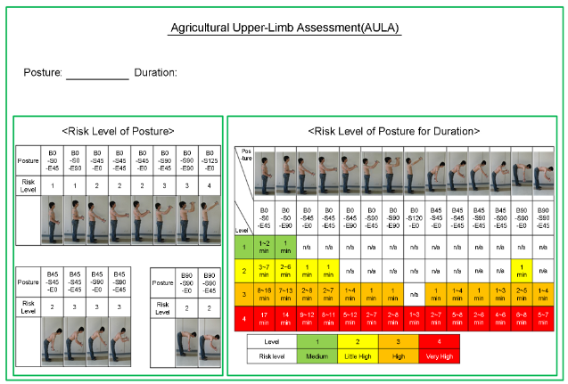

Figure 1. Work Posture Assessment Worksheet using AULA.

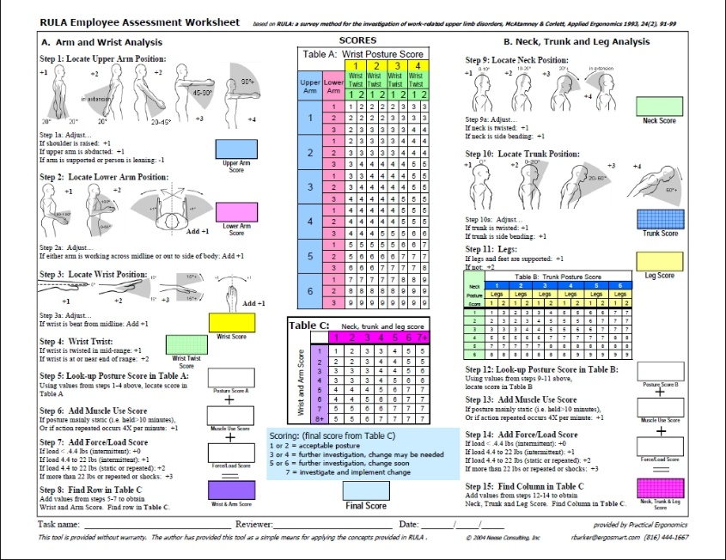

Figure 2. Work Posture Assessment Worksheet using RULA.

Pictures of the work postures of each activity are also given to experts to estimate the ergonomics risk value. A total of twelve experienced experts in ergonomics, safety and health, and agriculture participated in this study. The expert assesses with a 10-level rating scale: 1 = very safe posture to 10 = precarious posture. Then the risk level score estimated by the experts was calculated on average and classified into four levels (1= low (average: 1.00–3.25); 2: moderate (average: 3.25–5.50); high (average: 5.50–7.25), and 4: very high (average: 7.25–10.00). This classification is intended to homogenize the level of risk groups under AULA and RULA, each of which has four levels of risk.

Furthermore, several statistical analyses were performed to confirm whether the assessments of AULA and RULA match with the experts. There are hit rate analysis, squared-weighted kappa analysis, and independent t-test. The hit rate analysis was conducted to compare the assessment of the expert and each method. The squared-weighted kappa analysis was performed to measure agreement between the result of experts and the evaluation tools. Based on the Kappa score analysis criteria shown in Table 1 [14], the analysis was performed. Based on this quadratic kappa analysis, it will be obtained which method is most appropriate for the expert's assessment, which means that this method is the most suitable to be applied to measure the ergonomic risk of work posture in oyster mushroom cultivation activities. Meanwhile, the independent t-test was conducted to test the significance between the expert assessments and the AULA or RULA calculations, whether they had the same assessment or were significantly different. In addition, an independent t-test was conducted to compare whether there was a significant difference in the assessments between AULA and RULA.

**Table 1.** Kappa Analysis Criteria (K).

|  |  |
| --- | --- |
| **Kappa (K)** | **Strength of Agreement** |
| <0.20 | Poor |
| 0.21 – 0.40 | Fair |
| 0.41 – 0.60 | Moderate |
| 0.61 – 0.80 | Good |
| >0.80 | Very Good |

**3 Results and Discussion**

**3.1 Hit rate analysis**

The hit rate analysis was performed to examine how well the experts’ assessment matched with the risk level assessment of evaluating tool for 26 activities of oyster mushroom production. The hit rate between experts' and RULA assessments was 71% for risk level 2 and 58% for risk level 3. Hit rate result of the AULA assessment also showed 86% matched with experts’ assessment for risk level 2 and 68% for risk level 3. The average of matching expert assessment was 62% for RULA and 73% for AULA. Based on hit rate analysis, AULA was better well-matched with the expert assessment.

**Table 2.** Risk level distribution of RULA and AULA compared with expert assessment.

|  |  |  |  |  |  |  |  |  |  |  |
| --- | --- | --- | --- | --- | --- | --- | --- | --- | --- | --- |
|  |  | RULA | | | |  | AULA | | | |
|  |  | 1 | 2 | 3 | 4 |  | 1 | 2 | 3 | 4 |
| EXPERT | 1 |  |  |  |  |  |  |  |  |  |
| 2 |  | **5** | 2 |  |  | 1 | **6** |  |  |
| 3 |  | 6 | **11** | 2 |  |  | 5 | **13** | 1 |
|  | 4 |  |  |  |  |  |  |  |  |  |

**3.2. Quadratic Weighted Kappa Analysis**

Table 3 shows the level of agreement between expert assessment and the existing ergonomic tools for upper limb (i.e., RULA and AULA) using Quadratic weighted kappa analysis. Kappa's value of experts' evaluation and AULA evaluation was 0.483, with moderate consistency. The kappa value between the experts' results and the RULA results showed an acceptable level of agreement of 0.261. Thus, based on weight quadratic Kappa analysis, AULA agreed more with expert assessment than the RULA methods.

**Table 3.** Quadratic Kappa Analysis of AULA and REBA.

|  |  |  |  |
| --- | --- | --- | --- |
| **Assessment Tool** | **Percent of Agreement (%)** | **Kappa Value** | **Strength of Agreement** |
| **AULA** | 48.3% | 0.483 | Moderate |
| **RULA** | 26.1% | 0.261 | Fair |

**3.3. T-Test Analysis**

The t-test analysis result showed that the risk levels between RULA and AULA and expert assessment were not statistically different (α > 0.05), as presented in Tables 4 and 5. When RULA was compared with AULA, the t-test result showed that the risk levels between the two methods were not statistically different (α > 0.05), as shown in Table 6. Since the average risk level of AULA was not significantly different from RULA, it could be predicted that the risk level of these two methods and expert assessment would not be different. Although RULA and AULA were developed to evaluate upper segment working posture, the criteria used to determine the score in those methods are different.

**Table 4.** Result of t-test between AULA and expert assessment.

**Table 5.** Result of t-test between RULA and expert assessment.

**Table 6.** Result of t-test between AULA and RULA.

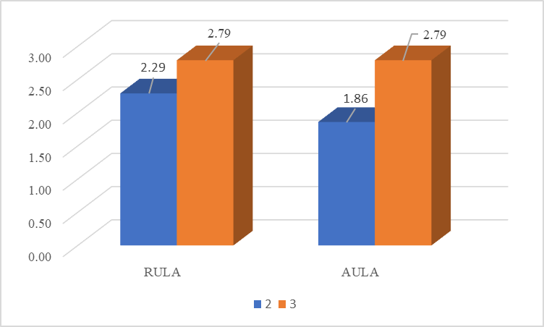

Figure 3. Comparison between RULA, AULA, and expert assessment.

Compared with the experts' working posture rated as risk level 2, RULA showed a higher risk level (0.29), and the AULA assessment tool showed undervaluation (- 0.24), as shown in Figure 1. For working posture, rated as risk level 3 by the experts, all the ergonomic evaluation tools showed undervaluation, RULA, and AULA (- 0.21). Despite the difference between experts and the two ergonomics methods' assessment, RULA and AULA risk levels were not statistically significantly different from the experts' assessment (α > 0.05).

Although AULA and RULA were developed to evaluate upper limb working posture, the criteria used to determine those methods' scores are different. AULA assesses 14 upper limb postures. The upper limb postures are evaluated by observing the angle of the trunk combined with the tip of the upper arm and lower arm. In determining the risk score, AULA considered the duration of each posture. On the other hand, RULA determines the risk level by assessing the angle of 6 body segments (i.e., neck, trunk, lower arm, upper arm, wrist, and leg) separately.

Furthermore, in the case of RULA, points can add to the total posture score if one or more body parts are held for longer than 1 minute, and an additional one more point also can be added if the frequency of activity is more significant than four times per minute. These methods use the same criteria for calculating the risk regardless of the posture that experiences those conditions. According to the previous study by Kong et al., the difficulty level of each posture while experiencing those conditions (i.e., static workload, repetitive movement) are different. Therefore, this additional point might overestimate or underestimate the risk level [13].

**4 Conclusion**

In summary, based on all analyses (Hit rate, Quadratic Weight Kappa, and t-test analysis), the risk assessment using AULA in oyster mushroom farms was relatively well-matched to the expert subjective assessment other than RULA. Thus, this finding concluded that the AULA method would be an appropriate tool to evaluate the MSD risk of oyster mushroom farmers in Samarinda.

The limitation of this research is that the assessment tool used in the comparison is limited to RULA. Future studies could use a wider variety of ergonomic assessment tools to compare work postures in agricultural work, specifically for upper and lower extremity posture, and verify which assessment tools are most suitable for more specific pastoral work.

**References**

1. Badan Pusat Statistik Kaltim. Statistik Nilai Tukar Petani Provinsi Kalimantan Timur 2019. Kalimantan Timur. 2020.
2. Badan Pusat Statistik Kaltim. Produk Domestik Regional Bruto Provinsi Kalimantan Timur Berdasarkan Lapangan Usaha 2015-2019. Kalimantan Timur. 2020.
3. Dianat I., Afshari D., Sarmasti N., Sangdeh M.S., and Azaddel R. Work Posture, Working Conditions, Musculoskeletal Outcomes in Agricultural Worker. International Journal of Industrial Ergonomics. 2020; 77.
4. McAtamney L. and Corlett E.N. RULA: A Survey Method for The Investigation of Work-Related Upper Limb Disorders. Applied Ergonomics. 1993; 24(2):91-99.
5. Jain R., Meena M.L., Dangayach G.S., Bhardwaj A.K. Risk Factors for Musculoskeletal Disorders in Manual Harvesting Farmers of Rajasthan. Industrial Health. 2018; 56(3):241-248.
6. Kumar P., Chakrabarti D., Thaneswer P., Chowdhury A. Work-Related Pains Among the Workers Associated with Pineapple Peeling in Small Fruit Processing Units of North East India. International Journal of Industrial Ergonomics. 2015; 53:124-129.
7. Thetkathuek A., Meepradit P., Sa-Ngiamsak T. A Cross-sectional Study of Musculoskeletal Symptoms and Risk Factors in Cambodian Fruit Farm Workers in Eastern Region, Thailand. Safety and Health at Work. 2018; 9(2):192-202.
8. Mishra D. and Satapathy S. Ergonomic Risk Assessment of Farmers in Odisha (India). International Journal System Assurance Engineering Management. 2019; 10(5).
9. Kong Y. K., Lee S. J., Lee K. S., Han J. G., Kim D. M. Development of an Ergonomic Checklist to investigate Work-related Upper Limb Disorders in Farming – AULA: Agricultural Upper-Limb Assessment. Journal of the Ergonomic Society of Korea. 2011; 30(4):481-489.
10. Choi K.H., Kim D.M., Cho M.U., Park C.W., Kim S.Y., Kim M.J., Kong Y.K. Application of AULA Risk Assessment Tool by Comparison with Other Ergonomic Risk Assessment Tools. International Journal of Environment Research and Public Health. 2020; 17(18).
11. Kong Y.K., Lee S.Y., Lee K.S., Kim D.M. Comparisons of Ergonomic Evaluation Tools (ALLA, RULA, REBA, and OWAS) for Farm Work. International Journal of Occupational Safety and Ergonomics. 2018; 24:218-223.
12. Kong Y.K., Lee S.J., Lee K.S., Kim G.R., Kim D.M. Development of an Ergonomics Checklist for Investigation of Work-Related Whole-Body Disorders in Farming-AWBA: Agricultural Whole-Body Assessment. Journal of Agricultural Safety and Health. 2015; 21(4):207-215.
13. Blackman N.J.M. and Koval J.J. Interval Estimation for Cohen’s Kappa as A Measure of Agreement. Statistics in Medicine. 2000; 19(5):723–741.