Ethnobiology Study: Game in Dayak Lun Dayeh Community at Watershed of Mentarang in Malinau

Medi Hendra*, Dijan Sunar Rukmi, Surianto Effendi, Freminci , Auliana

Department of Biology, Faculty of Mathematics and Natural Sciences, Mulawarman University, Jl. Barong Tongkok, Kampus Gunung Kelua, Samarinda, Indonesia 75123

Abstract
Dayak Lun Dayeh is one of local community who lives in East Kalimantan, where they’ve practiced hunting traditionally and in modern way, has particular ways to find hunting spot and use hunting techniques. The research about this community was conducted in watershed of Mentarang, in order to determine the various kinds of game, frequently used hunting location, and hunting ways of Dayak Lun Dayeh community at two different times, on May−July 2016 and June−August 2021. Research data were collected through open ended interview (assisted by key informant), field observation and photographic record. Data were presented descriptively by ethnobiology approach. The results showed that this community practices subsistence hunting of games, which comprised of mammals (69−73%), reptiles (14−15%), aves (8%), and amphibians (0−4%). The bush meat obtained from hunting(s) were consumed as protein source, served as medium in traditional ceremonies or religious rituals based on ancestral teachings. Games such as Cervus unicolor, Sus barbatus, Muntiacus atherodes could be found easily at abpa’ nuvan (salt-lick) rather than at primary forest, swidden (latii), swidden fallow (included amug, jekau and ripa), farm, river, or secondary forest such as the logging roads of former timber company. Several hunting techniques were applied such as using hunting dogs for tracking the games (gelibut), sieging or waiting (gabang) at specific location (abpa’ nuvan), and setting traps (ton).

Keywords: Dayak Lun Dayeh, hunting, locals, wild life
*Correspondence author, email: medihendra@fmipa.unmul.ac.id

Introduction
Originally, the Dayaks believe in traditional way along with cultural boundaries and simple technology to protect the forest and wild life at their places. However, those things were disappeared since many years ago, caused the forest degradation and loss inhabitants, such as mammals. Several remote area, surrounded by mountains are perfect location to be managed as wildlife sanctuary thus preserves the wild life. Therefore, Dayaks are eligible to protect their highly valuable area as well as to guide the tourists (or people from the outside), because of their extensive knowledge about forest and its inhabitants (Mackinnon, et al. 2000). Approximately 25,000 of residents at Kayan Mentarang National Park in Malinau and Nunukan Regency of North Kalimantan are Dayaks and they are very dependent from forest for almost all their life necessities, started from food sources (such as upland rice or beras gunung and animal protein), building materials, medicines, water, source of cash, and help preserving their culture (Barr et al., 2001; Uluk et al., 2001; Joshi et al. 2004).
Local people have consider the importance of primary forest based on following things: a) as source of livelihood (directly or indirectly), b) the existence of historical values that must be preserved until the next generation, and c) has abundant of natural resources with great value obtained from plants and animals. Based on local view, the other type of lands has lower value than forest (Sheil et al., 2009). However, Sheil et al. (2004) proposed that the interest or the utilization of forest is determined from the distance of forest itself to local village. The lower the distance, the higher chance of locals used or utilized natural resources and even managed activity such as hunting in the forest. Hence, one of the most well-known communities who practiced hunting activity in daily lives is Dayak.
Dayak is the largest tribe who lives in the remote area of north Kalimantan. Dayak tribe inhabits the river upstream and other lowland areas, even in more isolated area. Some of them are nomadic but the rest lives in groups at different places. Most people in this community use river as main transportation for daily activities. The Dayak community consists of a few ethnic Dayaks with different language and culture. At first, Dayak in Borneo is divided into seven major ethnics viz. Ngaju, Klemantan, Apo Kayan, Ot Danum, Punan, Murut, and Iban. The previous seven ethnics then sub-divided into 18 sub-tribes (tribal children) and 405 smaller sub-ethnic groups (Coomans, 1987; Riwut, 2007; Hidayah, 2015; Zainuri, 2018). In our studied area, there is one sub-tribe, which called Lun Dayeh and they apply distinctive customary law by themselves (Wulffrat, 2005).
Migration of tribal people from Dayak Lun Dayeh to watershed of Mentarang has occured since the head-hunting and ancient tribal war time. Y. Daring recounted that “the migration started from the Krayan region along the Kayan River, Puruk River, Mentarang River, and the smaller river to find fertile area that would be maintained to develop traditional farms and harvest forest products” (personal communication, June 05, 2016). The migration process occurred gradually and led by an elder for each group. F. Yakub narrated that “tribal wars between Dayak Lun Dayeh and Dayak Abay at Long Berang Village were won by Dayak Lun Dayeh, made that area owned by Dayak Lun Dayeh, then they managed as residential area (or referred as riverine colonist)” (personal communication, June 05, 2016). Y. They told us “in 1980s (before the expansion of Malinau District), the government of Bulungan District relocated Lun Dayeh community, then cause the new setlement along the upstream of Mentarang River (Long Berang, Long Gapit, Long Bisai) to the Singai Terang village, in order to facilitate better access for children education, economy, and administrative service” (personal communication, June 05, 2016). However during the previous journey, there are people who could not survived and decided to return to their homeland. Levang et al. (2009) mentioned that all communities that depend on forests in Malinau, have been exposed to changes up to certain degree in the political and socio-economic sector since the district has been developed. People who lived close to the capital of Malinau district undergo substantial changes, whereas people who lived in remote areas, such as river upstream were experienced fewer changes.
According to Iskandar and Iskandar (2017), study on ethnobotany, ethnoecology and ethnozoology has an important role and significant contribution on relationship of locals toward natural resources and their surrounding environment. The traditional knowledge system/cognitive knowledge (corpus), deep insight or belief by locals (cosmos) and traditional culture were developed by environmental factor thus would maintain high biodiversity in their area (Joshi et el., 2004). In order to obtain the daily needs, locals who lived in Kayan Mentarang and adjacent area practice swidden agriculture, wet rice cultivation, hunting, fishing and collecting forest products (Eghenter & Sellato, 2003). Besides to fulfill animal protein or practice livestock cultivation, hunting activity could provide a better income to locals by selling the games in the fresh market (Konradus, 2003). Generally, Dayaks in East and North Kalimantan depend on nature, cultivate their rightful lands, hunting, fishing, and yield forest products in less modern way to fulfill their daily needs (Frans, 2003). Thus, this study is important to determine whether the hunting level at present still guarantee the animal biodiversity for the next years. The aims of this research were to determine the hunting activity of Dayak Lun Dayeh community based on their traditional and modern way, discover the location commonly used for hunting and learn hunting techniques used by locals daily. Furthermore, we explore the possibility of conservation and wisdom by locals in order to avoid over-hunting in this community.

Methods
The research was conducted from May until July 2016 in three large villages at watershed of Mentarang River followed by the next research on June to August 2021 at Mentarang Sub-District, Malinau District (Figure 1). In 2016, we conducted the first research as preliminary study, while at 2021 we focused more on conservation aspect. The zoological data were collected and we conducted semi-structured interview (Ellen, 1993). The interviews were managed by open ended interviews, followed by field observation, captured image of games and their identification. As interviewee, they are hunter, blowgun artist, village head or kepala desa, traditional leader or kepala adat, respected villager or tetua, and locals. Before interview, we brought pre-prepared questionnaire sheets to studied area (Supiandi et al., 2021).
Open ended interview was assisted by key informants, which are people who expert in hunting, participated in small to large scale hunting(s) and had small talks with local youth who enjoy hunting activity. On the second research, we specifically applied purposive sampling to determine our informants. We opt only local people, know about hunting, understand culture or traditional customs, aged more than 19 years old and stayed in studied area more than 5 years (Firdaus et al., 2019). Our observation started from following hunters (key informant), local youth and locals who intend to hunt in the forest. Along the journey, the interviewee was asked about hunting (his thought or observation freely), while we would ask more detailed questions on any matters regarding hunting (Eghenter & Sellato, 2003). Any game encountered by hunter were recorded. In any occasions, we could not participate in hunting activity, therefore we asked locals about the hunting location, animal behavior and their habitat. Different from the past, on the last research, we asked 19 participants from locals as representative from each household at studied location, which consisted of 6 men and 13 women. These interviews gave more variable results because not only we collected data from fresh hunted games and but also the artifacts made from animal products as well. The first study only obtained fresh (dead/alive) games from hunting activity. Our observation continued as we took photo all the journey and interview, all photo from the games, remain of the games (dried skin or skull), games found around the longhouse or field. A number of games were captured live, half damaged or even dead cause by blowgun, gun or trap.
All data from open ended interviews have gotten permission to be published from all speakers. We realize that all results about research substance was belonged to Lun Dayeh community, including verbal information and biological response. We had asked the approval from locals, therefore they gave us information freely, autonomy, and voluntary after they fully understand about our research, especially the benefit and risk after participated in it. Moreover, one of our authors is native from Lun Dayeh community (Freminci). At first, she sought kepala adat (traditional leader), kepala desa (village head), or tetua (respected villager), where she gave them short introduction, objectives, working plan (or methods) of our research, then she asked permission from them to conduct interviews to locals, especially hunters or anyone who has experience in hunting activity or related to hunting (Saragih, 2011).
Field observation data contain vernacular name, Indonesia name, scientific name and their family, and results from 2016 and 2021 were presented in Table 1. Game species was identified based on the mammals of Borneo, Sarawak, and Sabah (Payne et al., 2000); mammals of Gunung Kabut National Park in West Java (Suyanto, 2002); birds of Sumatera, Java, Bali, and Kalimantan (MacKinnon et al., 1992); reptiles and amphibians (Iskandar, 1998), and freshwater fishes of Western Indonesia and Sulawesi (Kottelat et al., 1993). All data from interviews, field notes, the games, were described qualitatively, filled in table, or displayed in percentage using pie chart.

Results and Discussion
Hunting activity Hunting(s) in Dayak Lun Dayeh community are well known as ngilip or nganup, considered as an important activity, although it would not classified as one of main activity in their daily life. According to government regulation (Minister of Environment and Forestry of Republic of Indonesia, Number P.20/MENLHK/SETJEN/KUM.1/6/2018 and newer version Number P.106/MENLHK/SETJEN/KUM.1/ 12/2018) hunting activity by this community was aimed to fulfill protein requirement, therefore this activity could be considered as subsistence hunting. This practice tends to be more beneficial for family consumption or the food security and it was more important than commercial purpose (economy). Basically, animal protein source in Dayak Lun Dayeh was obtained from fish, but fishing could not be categorized as hunting. The main activity of this community were farming, gardening, and harvesting gaharu (Aquilaria spp.) especially for man, in remote area of forest due to its high economic value.
Y. Murang told us that “the hunting activities along Mentarang river have changed significantly at the moment, especially for people who live near capital city” (personal communication, June 05, 2016). Their dependence on game have been far decreased than people who live around Mentarang River. Different from the past, hunting is currently practiced only for pleasure or meet requirements for large ceremony, such as wedding (irau awe), welcome ceremony for important guest, or district head. Hunting would be practiced eventually, if the traditional market could not fulfill their needs for bush meat to serve at those occasions (Figure 2). Occasionally, hunting was practiced in slack period, while managing rice field, harvesting gaharu, or on the way home from previous trip.
Games hunted from this community were varied, grouped by purpose, hunter age, hunter skill and natural factor. This result was obtained from our interviews with locals. Preys such Macaca fascicularis, Presbytis hosei, and Trachypithecus cristatus could be captured only by experienced hunters. The body parts of Sus barbatus, M. fascicularis, P. hosei, T. cristatus, and Python reticulatus were processed to decorate their long house or traditional clothes, even at their traditional weapon (Figure 3). According to Government Regulation Number 13/1994, explained that the animals hunted (game) are unprotected wild animals only. Game is classified into small, or large animals and the bird species. The category of bird in this regulation encompasses all types of wild bird in nature.
Dayak Lun Dayeh was known as omnivorous, where they could consume any type of games, except the crocodile as they regarded it as tribal symbol. The other tribe from Flores, viz. Manggarai also did protection to their natural resources by protect and conserve such particular area as sacred forest, establish local idioms, or intensify role of local institution on conservation. Moreover, they preserve some local species as sacred species or consider it as significant species; ecology and utilization of non-timber resources in sustainable way (Iswandono et al., 2015). Based on the obtained data from the first observation at 2016, about 73% of games hunted by Dayak Lun Dayeh at those locations were mammals (Figure 4, left), especially large mammals that were easily found in Malinau forests. Large mammals whom became the target of hunting were family Cervidae, like fayo (C. unicolor), talau (M. atherodes); family Suidae like babui (S. barbatus); and family Ursidae (H. malayanus). The others are Cercopithecidae like kuyad (M. fascicularis), becuk (M. nemestrina); and P. hosei; the last game was hunted as it was considered as pest. Mammals were preferable hunted by locals, because they could harvest more portion of bush meat than any other classes. Secondly is reptile, approximately 15% of the game, a group that was incidentally observed or met in the forest, or sometimes it was caught in trap which is already prepared by hunters. Aves was 8 % of the game, especially the large aves where it could be consumed as protein source and occasionally to earn cash income. For example, helmeted hornbill (Rhinoplax vigil), where the casque has a high value in the black market (the older the casque, the higher its price), therefore the over hunting of it was happened more often in the local community. Amphibians (4%) were the smallest portion, it was hunted at night and consumed as side dish, while the hunter hunted at forest. There were slight differences from the results obtained at 2021, where they have captured less bush meat than previous research, especially for mammals and reptiles. They even had managed to not captured any amphibians in the last observation at 2021 (Figure 4, right). The first observed data from 2016 was less diverse than the next research because in the first study, the data obtained from dead/alive games or bush meat only (after hunting). Furthermore, the intensity of hunting activity was lesser than the first observation. This happened because the results were from the fresh hunting by locals and animal artifacts as well. This result was obtained presumably from the awareness of forest conservation by locals, assisted with the socialization by ranger and persuasive approach through ketua adat (traditional leader).
The problem arises from hunting activity was some game were categorized as protected species (mammals) and rare species (amphibians). Mammals such as orang utan was hunted to get its skull for souvenir (Mackinnon et al., 2000). Moreover, this community has been consumed several variants of frogs. It might possible that they accidentally consumed a new species, which has not been identified yet, it has already extinct. Meanwhile, we once told that hunter ever captured rangkong gading (Buceros vigil), extracted skull from its head, then sold off that skull to buyer from the outside. They did this action because, buyer would presumably give them higher price for each captured prey and the high demand of this animal products from overseas consumer. They could earn some money about IDR3 million kg⁻¹. If this practice continues, it would cause negative impact on diversity of wild animals in the future.

Folk classification by locals is a system of animal naming and was practiced by this community. It is happened naturally and based on their language and linguistics. Name of certain animal has been created and taught hereditary. The purpose of this activity is to introduce the animal species as well as to differentiate certain animals among them. Local names were created either from important body parts of species, the utilization or from their empirical experience.
According to Ellen (1993), language is basic and becomes very effective way for naming an animal. The human brain has limitation in storing information and remember everything. Therefore,culture was utilized as a mnemonic device to overcome the human limitation in examining, memorizing and storing information about all environmental aspects.
Dayak Lun Dayeh could modify their linguistic aspects in terms of naming (encoding) everything in their environment where they lived. Then it would simplify the understanding of communication among them. Although there are some differences between the language of Dayak Lun Dayeh in Malinau with Dayak Lun Dayeh in Nunukan, most of the Dayak Lun Dayeh use uninomial (single name) in naming of all creatures that exists in nature, in order to facilitate the communication. An example for previous act is kuyad (long-tailed macaque/M. fascicularis), sometimes uninomial name was used as a prefix of species with similar characteristic yet, it has salient feature, for example bird, where it is classified as Suiit (uninomial) into a suit menudun (rhinoceros hornbill/Buceros rhinoceros) or changes into binomial name. Ellen (1993) stated that the encoding constitutes the use of uninomial, binomial, and trinomial, even polynomial name, thus it is important to do in a modern way by taxonomic nomenclature where it consists of two or more segments morfosintactys.

Hunting tradition Tradition in hunting which came from Dayak Lun Dayeh’s belief, hunch and restriction still practiced lately, as it is considered as taboo, especially for locals who live far away the town. Taboo for hunters such as never ask the specific times for hunting, because if it is answered, the hunter would go back home by empty handed. Other belief, if encounters certain bird species, such as bird which called suit mengei and suit tik badan during hunting, they have to return immediately, because it is sign of bad luck (Figure 5). Furthermore, they should not grill the animal skin over 6 pm, because it could invite scary and horrible animal. Bush meat must be shared fairly, slaughtered from head to tail. The body part where the hunting dog has bitten usually are given to dogs.

Hunting location There is no standard rule in Dayak Lun Dayeh community regarding hunting location. They simply hunt based on where games come often or had been seen lately. Multiple locations were commonly used as a hunting ground, such as abpa’ nuvan (salt lick), an ecological term for an area, whose functioning as place by game to drink and lick the mineral salt, such as sodium. C. unicolor and M. antherodes are usually observed at the brine source. Montenegro (2004) also reported that salt lick could be found in certain area in varied habitats, frequently visited by game to lick or forage dirt. Salt lick was located at spring, and developed like puddle, sometimes in small upstream area of the forest. According to Barero (2006), the presence of game in salt lick was determined strongly by natural condition in the adjacent area and salt lick itself. In Dayak comunity, these places are very famous for hunting ground, although each tribe mentions it by different names and special terms, which is based on each area and the significance of its. For example, dayak community at our studied location named as abpa’ nuvan, while Dayak Benuaq named it as sopatn, or sepan-sepan from one Dayak tribe in Senamang river (Hendra, 2009).
Mammals and other games are hunted as well in the forest (fulung) which includes primary and secondary forests. According to Indriyanto (2006), forest or game are inseparable parts of the plant communities. In addition to plant consuming, animals make use of vegetation to migrate and manage daily activity, it was practiced by arboreal species including monkey, squirrel, tree tiger, gibbon, orangutan and bird species.
Hunting was conducted in secondary forest including forest patches or particular area whom experienced change in the composition of forest element. The forest were developed from open field such as unoccupied land of ex-timber company, the road opening among villages, and long abandoned road after timber company. Furthermore, hunters usually follow the migration of bearded pig (S. barbatus) based on the fruit ripening period (fung in Lun Dayeh language) which is started from northern to southern area of Borneo. These mammals are the most preferred species to be consumed among Dayaks.
Swidden (latii) is location to grow the upland rice. Hunting activity in this location intends only to hunt games which had disturbed farms (pest). Hunting in the garden also has similar with hunting way on the farm, apart from manage the garden, intensity of hunting depends on the number of pests.
River (abpa’) is location for hunting games whom drink usually at the creek. According to Mackinnon et al. (2000), watershed habitat supports games with high density, such as amphibians and water snakes. Large herbivores move from forest to outside for drinking or foraging plants at watershed. The bearded pig (S. barbatus) paw the herbs, while Sambar deer (C. unicolor) and barking deer (Muntiacus spp.) were foraging at night.
Swidden fallow is an area that was abandoned after cultivation period is over. Basically, this area is part of secondary forest as a result of succession. The location is intentionally left and expected to develop natural succession, therefore open area would re-covered by itself. The mentioned location could be planted with fruit tree as marker, to mark the area they had planted before, and sometimes it referred as jekau.
Swidden fallow (or shifting cultivation) are divided into 2 groups, Amug a plateau where it is still actively cultivated (estimate age 2−20 years), while Ripa is uncultivated land, would not be planted nor cultivated for long period (estimate age over 25 years). According to locals, hunting location was determined upon the games, thus they decided the hunting direction. However, not all places could be chosen or could be described as prohibited area for hunting ground. These places are private forest which belongs to certain people, protected area or indigenous forest under the authority of particular tribe, where they forbid outsider and only allow themselves for hunting or doing any activities in that area.
As result of regional government policy (regional autonomy established by Law Number 22/1999) the forest sustainability was seriously threatened either by granting rights to logging concession/concessionaire, mining management or illegal logging. This incident has caused the wild animals losing their habitats, specifically for arboreal animals whom lost trees as food source, shelter, and nesting place. In order to reduce the negative effect of over hunting, the Dayaks has unwritten rule, where they prohibited anyone to conduct hunting activity in custom forest to preserve the natural resources within. At present day, Dayak Lun Dayeh still would not allow oil palm plantation within their area.

Hunting techniques The hunting activities were grouped into two categories i.e. active and passive hunting. Active hunting spends a lot of energy and time precisely to track down the game, while passive hunting requires less energy to set trap at certain location, then waiting for the desired game to approach and trap it.
Here are some commonly used techniques by locals: 1) gelibut is a technique accompanied by dog, using spear, blowgun and gun while practiced only at morning to noon. The hunter follows the track, where usually passed by game or common place for game foraging. They also consider that chasing it by following downwind way; 2) gabang (eme gabang) is one technique by waiting and besieging game in the forest. This technique requires more than one person, for example hunting with gabang nuvan or around the salt lick (abpa’nuvan); and 3) hunting using trap. Ton/efung is a trap that usually practiced to capture fayo (the Sambar deer), baka (wild boar) and talau (kijang).

Traditional hunting tools Dayak Lun Dayeh has both traditional and modern ways for hunting activity. The traditional tools were made only from natural ingredients (Figure 6), while the modern tools were invented by human, such as gun and airgun (air rifle). All hunters of this tribe must own these equipments. In general, Dayak tribes in Borneo have tool similarity among them, such as blowgun, mandau (saber), and spear which are the primary tools. The slight differences are name used for tools, weapon shape, and materials used to produce tools. One example is blowgun = sipet (in Ngaju language), sipet (in Katingan language), and sopot (in Ot Danum language) (Riwut, 2007).

Blowgun production Blowgun (sumpit) and spear are traditional tools of this community. The tools were inherited from their predecessor. Blowgun (evut/etut in Lun Dayeh language) requires special skills and accuracy in order to drill, because it determines the outcome of the hole, either could it bent or straight, and its quality. Blowgun was created from one to seven days, depends on the wood material, the sharpness of iron drill to make hole and spare time of artist. The wood source is ipil wood (Intsia amboinensis) and ulin wood/tagas (Eusideroxylon zwageri). However, other people prefer to make blowgun from Ipil wood, because this species is easier to drill, while still wet (fresh cut), and it has soft fiber as well.
The bullet of blowgun (langan) was made of palm tree leaves (labing fulod = Arenga undulatifolia). Langan itself consists of head (arau), which is made of petiole cortex from Arau tree (Eugeissiona utilis), has function as catapult cork driven by wind. Once the dart (bullet) is finished, then inserted into telungan (bullet container). If user want to use the blowgun, bullet was dipped in poison of tree sap from Farir tree (Antiaris toxicaria).
The Farir sap is collected and stored in a container for 24 hours (one day and one night) until dry. After drying process finished, hunter stored it in smaller container for easier to carry, if hunter want to shoot the prey, the poison was re-wetted and the bullets were dipped in it. In other area, some hunters used tuber of Homalomena sp. to wet the blowgun bullets, therefore its toxin spread through game’s body quicker.

Modern hunting tools The circulation of guns in this community has caused the traditional ones being abandoned. The modern tools are more effective to immobilize games, especially the large mammals. Furthermore, the hunter doesn’t need to prepare poison for blowgun bullets, or spear and other materials, therefore the preparation time could be shortened. However, the use of modern tools has impact on the number of games, because it would cause over hunting.
Hunting activities (ngilip or nganup) in traditional way, basically was did only to fulfil protein needs, especially for people of inland Kalimantan. Hunting techniques such as gelibut, it could bring greater loss of animal biodiversity, if hunters intend to use modern tools like gun to capture prey for economical reason. The other techniques such as gabang and ton presumably harmless than gelibut, because it applied in less modern way. Abpa’ nuvan (salt lick), fulung (forest), latii (swidden), abpa’ (river), amug (new swidden fallow), and jekau (old swidden fallow) were places for doing hunting activity by locals. Despite of these various type of used lands, they still have places whom they dedicated to preserve the natural resources, namely customary forest. Indeed, traditional ecological knowledge and biodiversity conservation can support one for another to manage national park in Indonesia as such area established in customary forest (Susanti & Zuhud, 2019). There is Kayan Mentarang National Park in our studied area which is built to preserve natural resources. Lastly, the locals only prefer hunting practices at the forest along the Mentarang river on their territory to ensure the sustainability of animal diversity.

Conclusion
The game of Dayak Lun Dayeh community at the watershed of Mentarang River were consist of 69−73% mammals, 14−15% of reptiles (except crocodiles), 8% of bird species, and 0−4% of amphibians. From our observation, hunting mostly were held to meet protein need, special events, or religious ceremony that held since older generations, while the rest of body parts were processed into crafts. In short, hunting was practiced especially for consumption only. The locations were used as hunting ground for this community depends on the type of game to be hunted, such as the river (abpa’), primary and secondary forest, salt lick area (apa’ruvan), garden, swidden (latii), swidden fallow/jekau (amug and ripa). Other hunting techniques accompanied with dog(s) (gelibut) was performed to explore route that passed by game, and stalk or besiege it at certain location (gabang), and set trap using mesh (ton). In spite of their less harmful of traditional hunting (which is rare nowadays), we could not underestimate the possibility of loss animal diversity in the following years. Therefore, we urge locals and regional government to pay more attention in conservation and forest management sustainability to avoid the greater loss afterwards.

Acknowledgement
We acknowledge the support received from the locals at Malinau district for sharing their knowledge, particulary the village heads (Long Berang, Long Gapit, Long Bisai) in Mentarang for providing us valuabe information, in addition we want to thank Nur Rahman for kindly designing our research map.

References
Barero, C. M. L. (2006, January 26−31). Effects of human interaction on the frequency of“saltlick” use by lowland tapirs (Tapirus terestris) [Conference presentation]. Third International Tapir Symposium. Buenos Aires, Argentina.
Barr, C., Wollenberg, E., Godwin, L., Anau, N., Iwan, R., Sudana, I. M., Moeliono, M., & Djogo, T. (2001). The impacts of decentralisation on forests and forest-dependent communities in Malinau District, East Kalimantan. Bogor: CIFOR.
Coomans, M. (1987). Manusia Dayak dahulu, sekarang, masa depan. Jakarta: PT. Gramedia.
Eghenter, C., & Sellato, B. (2003). Introduction. In C. Eghenter, B. Sellato, & G. S. Devung (Eds.), Social science research and conservation management in the interior of Borneo: Unravelling past and present interactions of people and forests (pp. 1−33). Bogor: CIFOR, WWF Indonesia, UNESCO, and Ford Foundation. https://doi.org/10.17528/cifor/001238
Ellen, R. (1993). The cultural relations of classification. Cambridge: Cambridge University Press.
Firdaus, A., Kartikawati, M. S. & Roslinda, E. (2019). Etnoteknologi berburu Dayak Kubin di Desa Manggala, Kecamatan Pinoh Selatan, Kabupaten Melawi. Jurnal Hutan Lestari, 7(3), 1367−1378.
Frans-L., S. J. E (2003). Traditional property rights over land among the Kenyah of Pujungan Subdistrict. In C. Eghenter, B. Sellato, & G. S. Devung (Eds.), Social science research and conservation management in the interior of Borneo: Unravelling past and present interactions of people and forests (pp. 103−116). Bogor: CIFOR, WWF Indonesia, UNESCO, and Ford Foundation. https://doi.org/10.17528/cifor/001238
Hendra, M. (2009). Etnoekologi perladangan dan kearifan lokal masyarakat Dayak Benuaq di Kabupaten Kutai Barat, Kalimantan Timur [disertasi]. Bogor: Institut Pertanian Bogor.
Hidayah, Z. (2015). Ensiklopedi suku bangsa di Indonesia. Jakarta: Yayasan Pustaka Obor Indonesia.
Indriyanto. (2005). Ecologi hutan. Jakarta: BumiAksara.
Iskandar, D. T. (1998). Amfibi Jawa dan Bali. Bogor: Puslitbang Biologi-LIPI.
Iskandar, J., & Iskandar, B. S. (2017). Various plants of traditional rituals: Ethnobotanical research among the Baduy Community. Biosaintifika: Journal of Biology & Biology Education, 9(1), 114−125. https://doi.org/10.15294/biosaintifika.v9i1.8117
Iswandono, E., Zuhud, E. A. M., Hikmat, A., & Kosmaryandi, N. (2015). Integrating local culture into forest conservation: A case study of the Manggarai Tribe in Ruteng Mountains, Indonesia. Jurnal Manajemen Hutan Tropika, 21(2), 55−64. https://doi.org/10.7226/jtfm.21.2.55
Joshi, L., Wijaya, K., Sirait, M., & Mulyoutami, E. (2004). Indigenous systems and ecological knowledge among Dayak people in Kutai Barat, East Kalimantan–A preliminary report. Bogor: ICRAF Southeast Asia.
Konradus, B. (2003). Eaglewood and forest product management and trade in the Bahau River region. In C. Eghenter, B. Sellato, & G. S. Devung (Eds.), Social science research and conservation management in the interior of Borneo: Unravelling past and present interactions of people and forests (pp. 83−102). Bogor: CIFOR, WWF Indonesia, UNESCO, and Ford Foundation. https://doi.org/10.17528/cifor/001238
Kottelat, M., Whitten, A. J., Kartikasari, S. N., & Wirjoatmodjo, S. (1993). Freshwater fishes of western Indonesia and Sulawesi. Singapore: Periplus Editions.
Levang, P., Sitorus, S., Abot, A., & Mamung, D. (2009). Trade-offs and alternative livelihoods of forest dependents people in the Malinau research forest. In P. Gunarso, T. Setyawati, T. Sunderland, & C. Shackleton (Eds.), Managing forest resources in a decentralized environment: Lessons learnt from the Malinau research forest, East Kalimantan, Indonesia (pp. 9−26). Bogor: CIFOR.
MacKinnon, J., Phillipps, K., & Balen, B. V. (1992). Birds of Sumatra, Java, Bali and Kalimantan. Bogor: PuslitbangBiologi-LIPI.
MacKinnon, K., Hatta, G., Halim, H., & Mangalik, A. (2000). Ecology of Kalimantan: The ecology of Indonesia series volume III. Jakarta: PT. Prenhallindo.
Montenegro, O. L. (2004). Natural licks as keystone resources for wildlife and people in Amazonia [dissertation]. Florida: University of Florida.
Payne, J., Francis, C. M., Phillipps, K., & Kartikasari, S. N. (2000). Mammals at Kalimantan, Sabah, Sarawak and Brunei Darussalam. Bogor: The Sabah Society and Wildlife Conservation Society.
Riwut, T. (2007). Kalimantan membangun alam dan kebudayaan. Yogyakarta: NR Publishing.
Hendra, M. (2009). Etnoekologi perladangan dan kearifan lokal masyarakat Dayak Benuaq di Kabupaten Kutai Barat, Kalimantan Timur [disertasi]. Bogor: Institut Pertanian Bogor.
Saragih, B. (2011). Economic value of non-timber forest products among Paser indigenous people of East Kalimantan [dissertation]. Leiden: Universiteit Leiden.
Sheil, D., Lisnawati, N., Indawan, A., & Sumardjo. (2004). Dayak Merap and Punan people’s perception of the importance of forest in a tropical landscape, Malinau, East Kalimantan. Jurnal Manajemen Hutan Tropika,10(2), 1−13.
Sheil, D., van-Heist, M., Liswanti, N., Basuki, I., & Wan, M. (2009). Biodiversity, landscapes and livelihoods: A local perspective. In M. Moeliono, E. Wollenberg, & G. Limberg (Eds.), The decentralization of forest governance: Politics, economics and the fight for control of forests in Indonesian Borneo (pp. 61−90). London: Earthscan.
Supiandi, M. I., Bustami, Y., Billy, P., Syafruddin, D., & Tarigan, M. R. M. (2021). Ethnozoology in the Dayak Iban community as consumption, medicine, artistic, mystical values, and pet animals. Journal of Hunan University (Natural Sciences), 48(1), 88−96.
Susanti, R., & Zuhud, E. A. M. (2019). Traditional ecological knowledge and biodiversity conservation: The medicinal plant of the Dayak Krayan people in Kayan Mentarang National Park. Biodiversitas, 20(9), 2764−2779. https://doi.org/10.13057/biodiv/d200943
Suyanto, A. (2002). Mammalia in Gunung Halimun National Park, West Java. Bogor: Puslit Biologi-LIPI.
Uluk, A., Suana, M., & Wollenberg, E. (2001). Forests of the Dayak dependence around Kayan Mentarang National Park. Bogor: CIFOR.
Zainuri, L. H. (2018). Dayak Lundayeh: A report from the border. CLC Web: Comparative Literature and Culture, 20(2), 1−10. https://doi.org/10.7771/1481-4374.3233
Wulffrat, S. (2005). An ecological overview of Krayan Darat and Krayan Hilir in Kayan Mentarang National Park in the heart of Borneo. Jakarta: WWF-Indonesia.

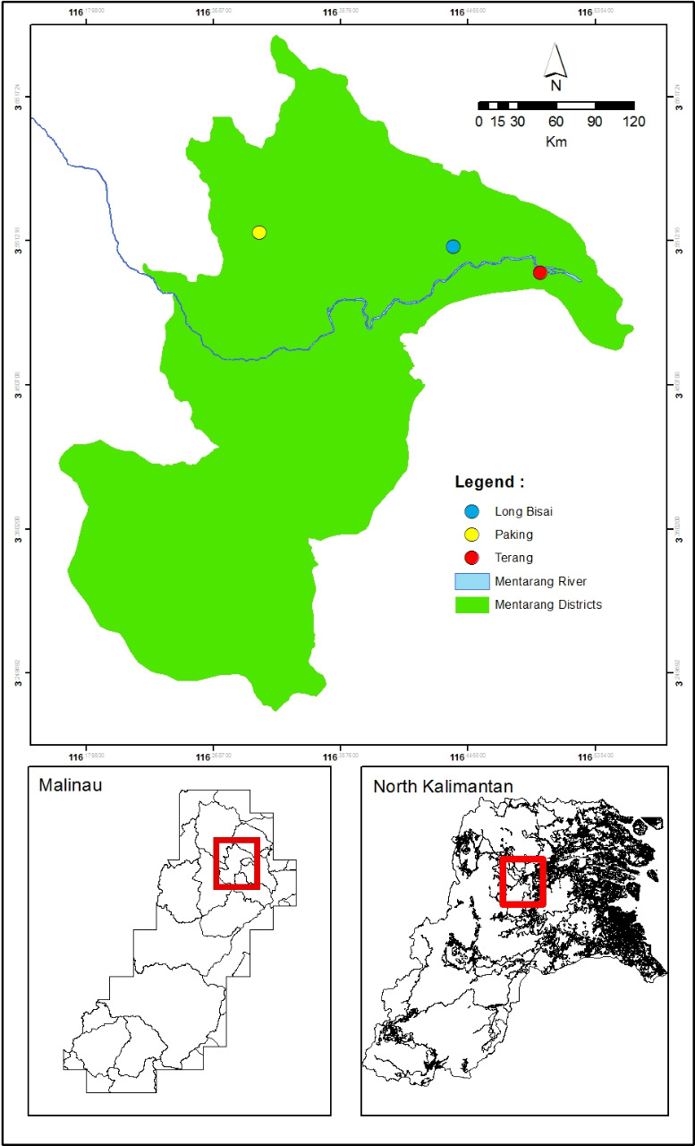
Figure 1 Three villages of research location at Mentarang Subdistrict, Malinau District of North Kalimantan.

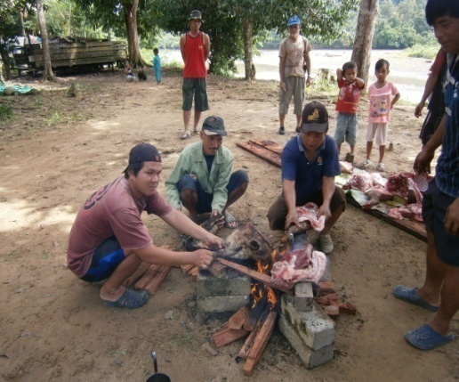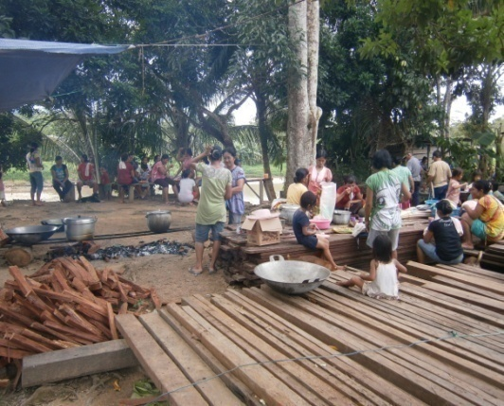

Figure 2 Burn boar skin to remove its hair (left); gotong royong (mutual assistance) in cooking raw meat to serve important guest (right).

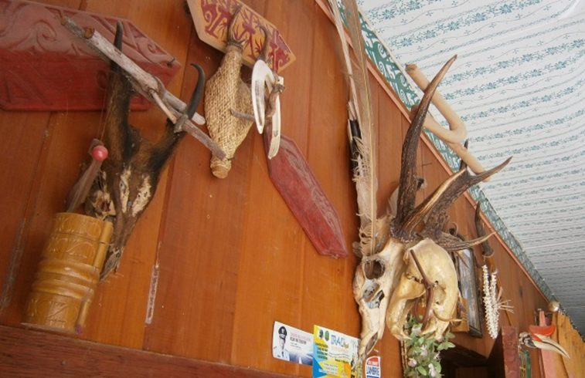
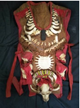 | 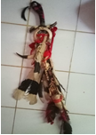

Figure 3 Artifact of games collected by locals (above); male traditional clothes (below left); and mandau (below right).

Figure 4 Composition of games hunted by locals at watershed of Mentarang in Malinau, North Kalimantan at 2016 (left) and 2021 (right).

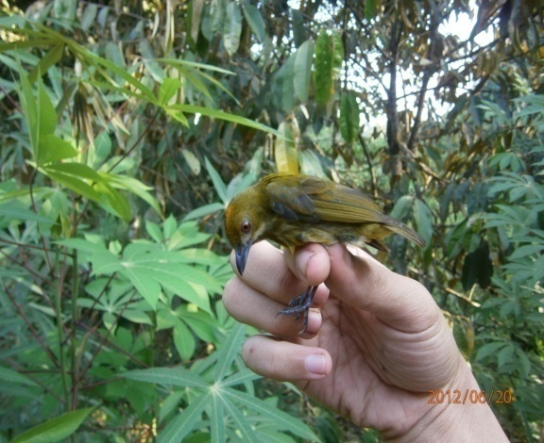

Figure 5 Bird: Suiit mengei (Prionochilus sp.) as sign of bad luck believed by locals.
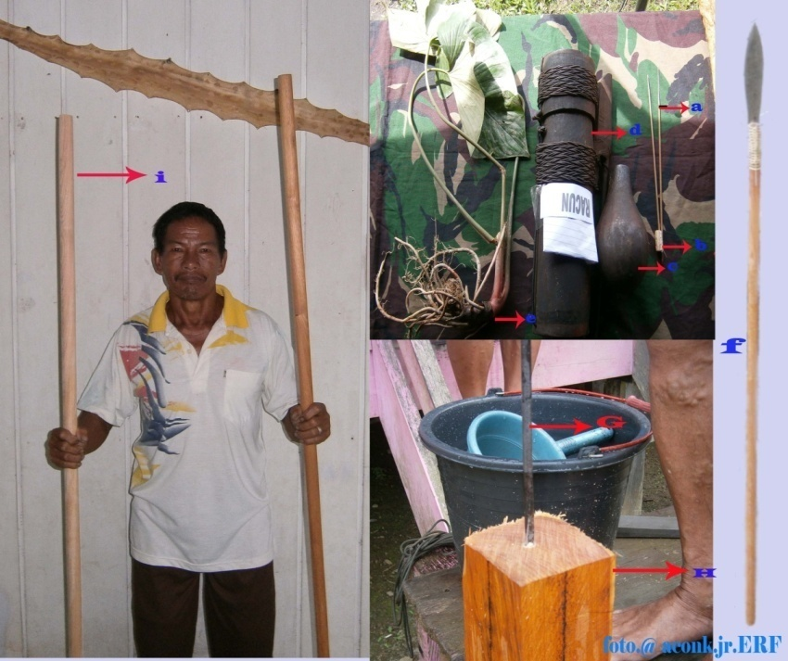
a
b
c
d
e
f
g
h
i
Figure 6. Blowgun (evut/etut) production by local artist; (a) langan; (b) cork booster (arau); (c) poison container; (d) telangan; (e) Homalomena sp.; (f) blowgun/evut (with spearhead at the end of blowgun); (g) blowgun drill; (h) ipil wood (raw material); (i) finished blowgun.

Table 1 Games hunted by Dayak Lun Dayeh (at 2016 and 2021)

No. | Vernacular name | Indonesian name | Scientific name | Family | 2016 | 2021
Mammals
1 | Kalio | Banteng | Bos javanicus | Bovidae |  | √
2 | Kambing | Kambing ternak | Capra hircus | Bovidae |  | √
3 | Bungkaro | Bekantan | Nasalis larvatus | Cercopithecidae |  | √
4 | Berangad | Lutung Banggat | Presbytis hosei | Cercopithecidae | √ | √
5 | Kelabet | Lutung kelabu | Trachypithecus cristatus | Cercopithecidae |  | √
6 | Becuk | Monyet beruk | Macaca nemestrina | Cercopithecidae | √ | √
7 | Kuyad | Monyet kra | Macaca fascicularis | Cercopithecidae | √ | √
8 | Talau | Kijang kuning | Muntiacus atherodes* | Cervidae | √ | √
9 | Talau | Kijang muncak | Muntiacus muntjac | Cervidae |  | √
10 | Fayo | Rusa sambar | Cervus unicolor* | Cervidae | √ | √
11 | Kubung mabu | Kubung malaya | Galeopterus borneanus | Cynocephalidae |  | √
12 | Tubang | Kucing batu | Pardofelis marmorata | Felidae |  | √
13 | Usi’ fulung | Kucing kuwuk | Felis bengalensis | Felidae | √
14 | Kuir | Macan dahan besar | Neofelis diardi | Felidae |  | √
15 | Kuir | Macan dahan | Neofelis nebulosi | Felidae |  | √
16 | Becuk | Owa kalawat | Hylobates muelleri* | Hylobatidae | √
17 | Afan | Landak raya | Hystrix brachyura | Hystricidae |  | √
18 | Terutung | Landak | Hystrix sp. | Hystricidae | √
19 | Arem | Trenggiling | Manis javanica* | Manidae | √ | √
20 | Sudu | Teledu sigung | Mydaus javanensis | Mephitidae | √ | √
21 | Dengen | Sero ambrang | Aonyx cinerea | Mustelidae |  | √
22 | Fawat | Kalong besar | Pteropus sp. | Pteropodidae | √
23 | Kelelit | Kalong besar | Pteropus vampyrus | Pteropodidae |  | √
24 | Temecur | Badak sumatra | Dicerorhinus sumatrensis | Rhinocerotidae |  | √
25 | Labo Saga | Bajing kelapa | Callociurus notattus | Sciuridae | √ | √
26 | Labo fur | Tangkarawak | Ratufa affinis | Sciuridae |  | √
27 | Babui/Baka | Babi berjenggot | Sus barbatus | Suidae | √ | √
28 | Ikau | Krabukuingkat | Tarsius bancanus* | Tarsiidae | √
29 | Pelanduk | Pelanduk kancil | Tragulus javanicus* | Tragulidae | √ | √
30 | Labo | Tupai bergaris | Tupaia dorsalis | Tupaiidae | √
31 | Labo fuan | Tupai kecil | Tupaia minor | Tupaiidae |  | √
32 | Labo siga | Tupai tanah | Tupaia tana | Tupaiidae |  | √
33 | Beruang | Beruang madu | Helarctos malayanus* | Ursidae | √ | √
34 | - | Binturung | Arctictis binturong | Viverridae |  | √
35 | Badan | Musang air | Cynogale bennettii | Viverridae |  | √
36 | Fugo | Musang akar | Arctogalidia trivirgata | Viverridae | √ | √
37 | Badan | Musang belang | Diplogalederbyanus | Viverridae | √
38 | Fayu | Musang luwak | Paradoxurus hermaphroditus | Viverridae |  | √
Aves
39 | Menudun | Rangkong badak | Rhinoplax vigil* | Bucerotidae | √ | √
40 | Menudun | Rangkong gading | Buceros rhinoceros* | Bucerotidae | √ | √
41 | Tuwao | Kuau raja | Argusianus argus | Phasianidae |  | √
Reptiles
42 | Ebu | Kura-kura bergerigi | Cyclemys dentata | Geoemydidae |  | √
43 | Menelen | Sanca kembang | Malayopython reticulatus | Pythonidae |  | √
44 | Menelen | Ular Phyton | Python reticulates | Pythonidae | √
45 | Ebuu | Kura-kura | Leucocephalon sp. | Testudinae | √
46 | Beladan | Labi-labi | Amyda cartilaginea | Trionychidae | √
47 | Lenei | Labi-labi hutan | Pelodiscus sp. | Trionychidae |  | √
48 | Kebaren | Biawak | Varanus salvator | Varanidae | √ | √
Amphibia
49 | Etit/Tiit | Katak | Rana sp. | Ranidae | √
Total |  |  | 49 specieses | 27 families

